Sales Trend Analysis for a Multi-Category Retailer

BA Capstone Project — Checkpoint 1: Data Fundamentals & SQL Querying
Talibon Polytechnic College
Course Code & Title: BED 106 — Business Analytics
Academic Year / Semester: A.Y. 2026–2027 · 1st Semester
Instructor: Jessie A. Melendres
Business Domain: Retail & Sales Analytics
Group Name / Number: Neo Tetras
Date of Submission: _______________________
Group Members & Roles
Member Name | Role
ALBER JUNE M. MUMAR | Project Lead / Analyst/ Data Engineer
JULEBETH HINLAYAGAN | Statistician / Modeler
MARDY GONZAGA | BI Developer / Visualizer
Table 1. Group members and assigned project roles.

Task 1.1 — Business Problem Statement

Business Domain & Problem Investigation
Industry: Multi-category retail (consumer electronics, furniture and office supplies) operating across six US states — California, Florida, Illinois, New York, Ohio and Texas.
Core business problem. The company grew out of 2020 and then stopped. On a like-for-like monthly basis revenue rose 30.9% between 2020 and 2022, from 92,934 to 121,648 per month, but has fallen in each of the two years since, ending 2024 at 100,207 per month — 17.6% below the 2022 peak. (2020 is measured per month because the dataset begins on 22 March 2020 and covers only nine complete months of that year; comparing its part-year total against a full year would overstate the growth.) Overall margin has stayed flat in a narrow 23.97%–26.93% band throughout, so the problem is not that the company is selling at worse prices; it is that the volume and mix of what it sells have shifted in a way management has not yet diagnosed.
Because reporting to date has been a single company-wide revenue figure per year, nobody can say whether the plateau is a market-wide slowdown, a seasonal artefact, or a handful of specific product lines falling away. Those three explanations call for completely different responses, and the company currently cannot tell them apart.
What this project does. It rebuilds five years of transaction history into a queryable relational warehouse and decomposes the trend along three axes — time, product hierarchy, and geography — so that the plateau can be attributed to specific product lines and specific periods rather than described in aggregate.

Business Impact & Significance
- Revenue. The gap between the 2022 peak and 2024 actuals is 257,297 per year. Recovering even half of it is worth roughly 128,000 annually, which is material against a five-year total of 5.91 million across the 57 complete months analysed.
- Inventory efficiency. Demand is heavily concentrated: October and December alone carry 21.8% of annual revenue, and Q4 as a whole carries 29.4%. Stocking to a flat monthly average guarantees both stockouts in the peak and dead capital in January, the weakest month at 4.72% of the year.
- Purchasing decisions. Category performance has diverged sharply. Knowing that Electronics fell 40.8% in 2024 while Office Supplies rose is the difference between an across-the-board purchasing cut and a targeted one.
- Reporting credibility. A documented, constraint-enforced schema replaces ad-hoc spreadsheet pivots, so every number in a management report can be traced back to a query and a source row.

Key Business Questions
- How have revenue and profit trended year over year from 2020 to 2024, and is the company still growing? (Answered by Q3, Figure 1.)
- Which product categories and sub-categories are driving the trend, and which ones reversed direction most recently? (Answered by Q5, Q7, Figure 3.)
- When during the year does demand concentrate, and is that seasonal pattern the same for every category? (Answered by Q4, Q8, Figure 2.)
Supporting questions: which cities return the most revenue per customer (Q6), and which bulk orders are being sold at the thinnest margins (Q2).

Data Source Overview
Historical point-of-sale transaction records — one row per product line on an order — obtained as a public CSV export in the Kaggle "Sales Dataset" format. The file covers 22 March 2020 to 15 March 2025 and carries order identifiers, dates, customer names, geography, a two-level product hierarchy, payment method, and the three measures: quantity, amount and profit.

Task 1.2 — Dataset Documentation

Data Source Report
Attribute | Details
Dataset Name | Sales Dataset (multi-category US retail transactions)
Source URL/File | https://www.kaggle.com/datasets/shantanugarg274/sales-dataset?
Date Accessed | 24 August 2026
License Type | Public/open dataset, used here for academic coursework only. _Confirm and record the exact licence shown on the source page before submission._
File Size | 1,194 data rows × 12 columns
Coverage | 22 March 2020 – 15 March 2025
Currency | Not stated in the source file. Amount and Profit are unitless integers; all figures in this report are quoted as currency units.
Table 2. Data source report for the sales transaction dataset.

Data Dictionary
Column Name | Data Type | Description
Order ID | VARCHAR(20) | Order reference label, e.g. B-26776. Not unique — see quality notes.
Amount | INTEGER → DECIMAL(12,2) | Revenue for the transaction line. Range 508–9,992.
Profit | INTEGER → DECIMAL(12,2) | Gross profit for the line. Range 50–4,930.
Quantity | INTEGER | Units sold on the line. Range 1–20.
Category | VARCHAR(60) | Top product level: Electronics, Furniture, Office Supplies.
Sub-Category | VARCHAR(60) | Second product level, 12 values, e.g. Printers, Sofas, Paper.
PaymentMode | VARCHAR(40) | COD, Credit Card, Debit Card, EMI, UPI.
Order Date | DATE | Transaction date, ISO YYYY-MM-DD. 648 distinct dates.
CustomerName | VARCHAR(120) | Customer full name, 802 distinct values. Not a unique key.
State | VARCHAR(60) | One of 6 US states.
City | VARCHAR(60) | One of 18 cities, 3 per state.
Year-Month | CHAR(7) | YYYY-MM. Fully derivable from Order Date — dropped as redundant.
Table 3. Data dictionary — column name, data type and description.

Preliminary Data Quality Assessment

1. Shape and coverage
Measure | Value
Rows in raw file | 1,194
Columns in raw file | 12
Earliest order date | 2020-03-22
Latest order date | 2025-03-15
Distinct Order ID values | 547
Distinct customer names | 802

Rows per calendar year:
Year | Rows
2020 | 171
2021 | 217
2022 | 288
2023 | 234
2024 | 240
2025 | 44 (partial - ends 15 March)

2. Missing values
Column | Null or blank
Order ID | 0
Amount | 0
Profit | 0
Quantity | 0
Category | 0
Sub-Category | 0
PaymentMode | 0
Order Date | 0
CustomerName | 0
State | 0
City | 0
Year-Month | 0
No column contains a null or blank value, so no imputation was needed.

3. Duplicates
- Fully identical rows: 0.
- Rows repeating the same (Order ID, Order Date, CustomerName, Sub-Category) combination: 36. These are kept as separate transaction lines, since a customer can legitimately buy the same sub-category twice on one order.
- Order ID is not unique: 547 distinct values cover 1,194 rows, and 194 of them appear against more than one order date or customer. It is therefore treated as a non-unique reference label (order_ref), not a primary key.

4. Inconsistencies
- Year-Month is fully derivable from Order Date (0 mismatches), so it is redundant and is recomputed in dates rather than stored twice.
- CustomerName is not a reliable identifier: 5 names appear in more than one city, so the customer key is (name, city).
- Negative Amount values: 0; negative Profit values: 0; rows where profit exceeds amount: 0; non-positive Quantity: 0. The measures are internally consistent.
- The 2025 rows stop on 15 March. Any year-on-year trend statement must exclude 2025 or label it as a partial year; dates.is_complete_year flags this.

Evidence that the dataset is synthetic
Four independent signals, all machine-checked:
- Zero loss-making lines across 1,194 rows and five years. Real retail carries returns, write-offs and discounted clearance.
- 22 of the 802 distinct customer names end in a credential suffix (MD, DDS, PhD, Jr...). This is the signature of the Python Faker library producing names like "Jason Smith MD", not a real customer list.
- US cities paired with UPI and EMI payment methods. Those are Indian payment systems; a retailer in Miami and Chicago would not offer them.
- Near-uniform payment mix: Debit Card 260, Credit Card 258, UPI 252, EMI 218, COD 206. Real payment mix is never this even.
This matters twice over. For Checkpoint 1 it means the figures should be presented as a modelling exercise, not a real company's results. For the Checkpoint 4 ethics report it means the customer names are not personal data - there is no data subject behind them - so R.A. 10173 is not engaged. Note the reason is that the names are generated, not that the file was publicly downloadable: public availability is not consent.

5. Cleaning steps applied
- Trimmed surrounding whitespace and normalised casing on all text labels (State, City, Category, Sub-Category, CustomerName).
- Cast Amount, Profit and Quantity to integers and Order Date to a true date type.
- Dropped the redundant Year-Month column and rebuilt the calendar attributes in dates.
- Replaced the unreliable Order ID key with a surrogate primary key sale_id, retaining the original value as order_ref.
- Split the flat file into seven dimension tables and one fact table, assigning surrogate keys and enforcing foreign keys.
- Verified referential integrity with PRAGMA foreign_key_check after load; the build fails if any violation is found.

6. Loaded row counts
Table | Rows
states | 6
cities | 18
categories | 3
sub_categories | 12
payment_modes | 5
customers | 807
dates | 648
sales | 1,194
Missing Values. None. All 12 columns are complete across all 1,194 rows, so no imputation or row-dropping was required.
Duplicates.
- Zero fully identical rows.
- 36 rows repeat the same (Order ID, Order Date, CustomerName, Sub-Category) combination. These were kept: one customer can legitimately buy two items from the same sub-category on one order, and the amounts differ between them.
- Order ID is not unique — 547 distinct values spread over 1,194 rows, and 194 of those values appear against more than one order date and a different customer name. It cannot function as a primary key.
Inconsistencies.
- Year-Month duplicates information already in Order Date (0 mismatches across 1,194 rows) — redundant storage and a future update anomaly.
- CustomerName is not a reliable identifier: 5 names appear in more than one city, so name alone cannot key a customer.
- Both ends of the series are partial. Data runs 22 March 2020 to 15 March 2025, so March 2020 and March 2025 are part-months and 2020 is a nine-month year. Two distinct traps follow. Read naively, the 44 rows of 2025 look like an 80% collapse in demand; and comparing 2020's part-year total against a full 2021 overstates growth (69.9% raw versus 30.9% on a like-for-like monthly basis). Including the 10-day March 2020 in a monthly average also drags that month's seasonal index down by 15%. dates carries two flags, is_complete_year and is_complete_month, and every trend query filters on them.
- Limitation worth stating — the dataset is synthetic. Four independent signals: zero loss-making lines across 1,194 rows and five years; 22 of the 802 distinct customer names ending in a credential suffix (MD, DDS, PhD), the signature of a name generator rather than a real customer list; US cities paired with UPI and EMI, which are Indian payment systems; and a near-uniform payment mix (206–260 lines each). Real retail data of this size would contain returns, discounts and loss-making orders. The methodology here is sound, but the specific figures should be presented as a modelling exercise rather than a real company's results.
- Privacy note. Because the customer names are generated, there is no data subject behind them and they are not personal data, so R.A. 10173 (Data Privacy Act) is not engaged. The reason is that the names are synthetic, not that the file was publicly downloadable — public availability is not consent.
Cleaning Steps Applied.
- Trimmed whitespace and normalised casing on all text labels (State, City, Category, Sub-Category, CustomerName).
- Cast Amount, Profit, Quantity to numeric types and Order Date to a true DATE.
- Dropped the redundant Year-Month column; rebuilt year, quarter, month and month name in dates.
- Replaced Order ID as a key with the surrogate primary key sale_id, retaining the original value as the descriptive column order_ref.
- Keyed customers on (name, city) rather than name alone.
- Added dates.is_complete_year and dates.is_complete_month so every trend query excludes the partial 2025 year and the two part-months (March 2020, March 2025) explicitly rather than by convention.
- Split the flat file into seven dimension tables and one fact table with enforced foreign keys; the build fails on any referential-integrity violation (PRAGMA foreign_key_check).

Raw Dataset Preview — first 10 rows
Screenshot 1 - https://www.kaggle.com/datasets/shantanugarg274/sales-dataset?
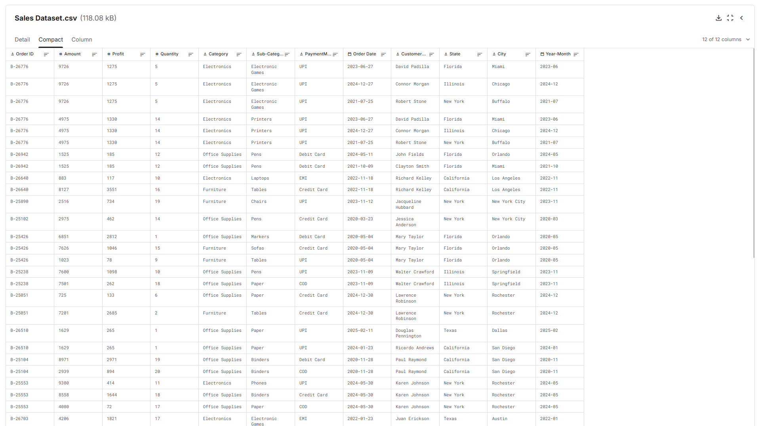
Table 4. Raw dataset preview, first rows as received.
_(Rows 1–3 above are exactly the evidence for the duplicate-key problem: one Order ID, three different dates, three different customers in three different states. Insert the full 10–20 row screenshot from your CSV viewer here.)_
Screenshot 2 – Downloaded CSV file (Sales Dataset.csv)
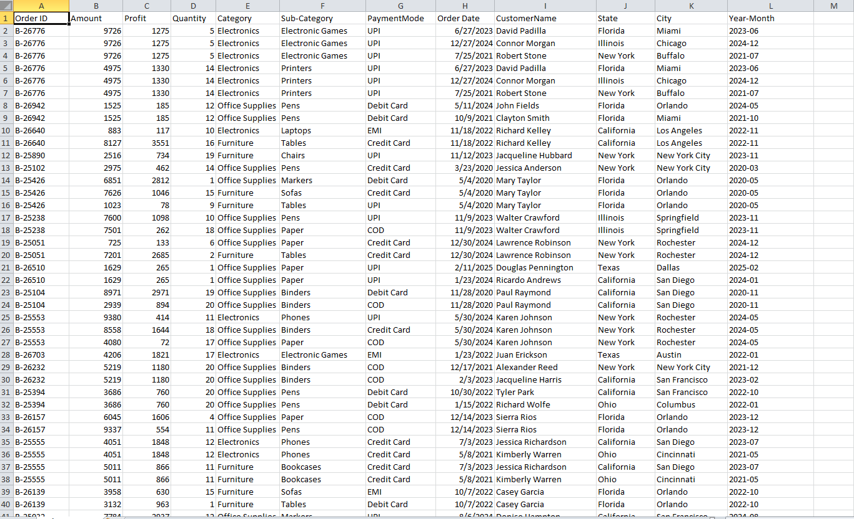

Task 1.3 — Relational Database Design

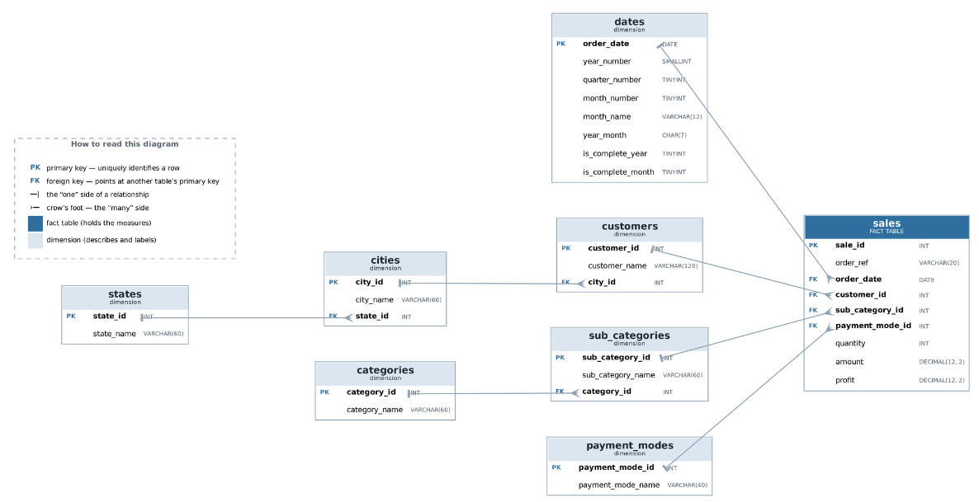
Entity-Relationship Diagram (ERD)

Star schema, 8 tables. sales is the fact table — it holds the additive measures (quantity, amount, profit) at a grain of one transaction line. The other seven are dimension tables, holding the descriptive attributes those measures are sliced by. The tables are named plainly rather than with fact_/dim_ prefixes; the roles come from the design, not the names.
Parent | Child | Cardinality
states | cities | 1 : many
cities | customers | 1 : many
categories | sub_categories | 1 : many
customers | sales | 1 : many
sub_categories | sales | 1 : many
payment_modes | sales | 1 : many
dates | sales | 1 : many
Table 5. Entity relationships and cardinality in the sales_trend schema.
Why this design. Every key business question in Task 1.1 has the form "a measure, sliced by a dimension, over time" — which a star schema answers in one join hop. Geography and product are kept snowflaked (state → city → customer, category → sub_category) rather than flattened, so a city or category label lives in exactly one place and Task 1.4 has genuine multi-table joins to demonstrate.

Database Schema & Population
Populated row counts (verified after load):
Table | Rows
states | 6
cities | 18
categories | 3
sub_categories | 12
payment_modes | 5
customers | 807
dates | 648
sales | 1,194
Table 6. Populated row counts verified after load.
The schema creates 8 primary keys, 7 foreign keys, 6 unique constraints and 4 check constraints, all verified on a live MySQL-compatible server; both foreign keys and check constraints were confirmed to reject invalid rows.
sales holds exactly the 1,194 rows of the raw file — no transaction was lost or invented in normalisation. customers has 807 rows against 802 distinct names, the 5 extra rows being the names that appear in more than one city.

Screenshot 1 – CREATE TABLE statements
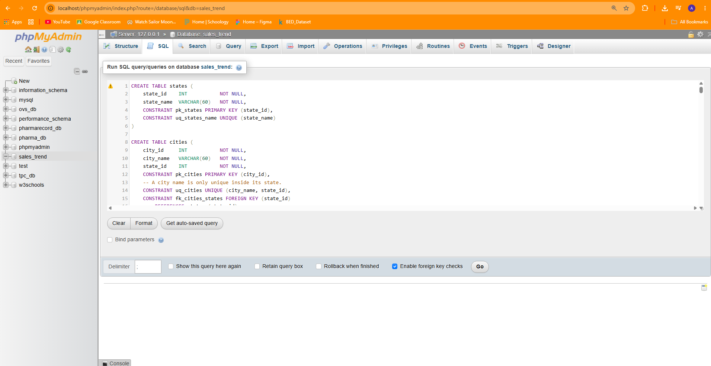

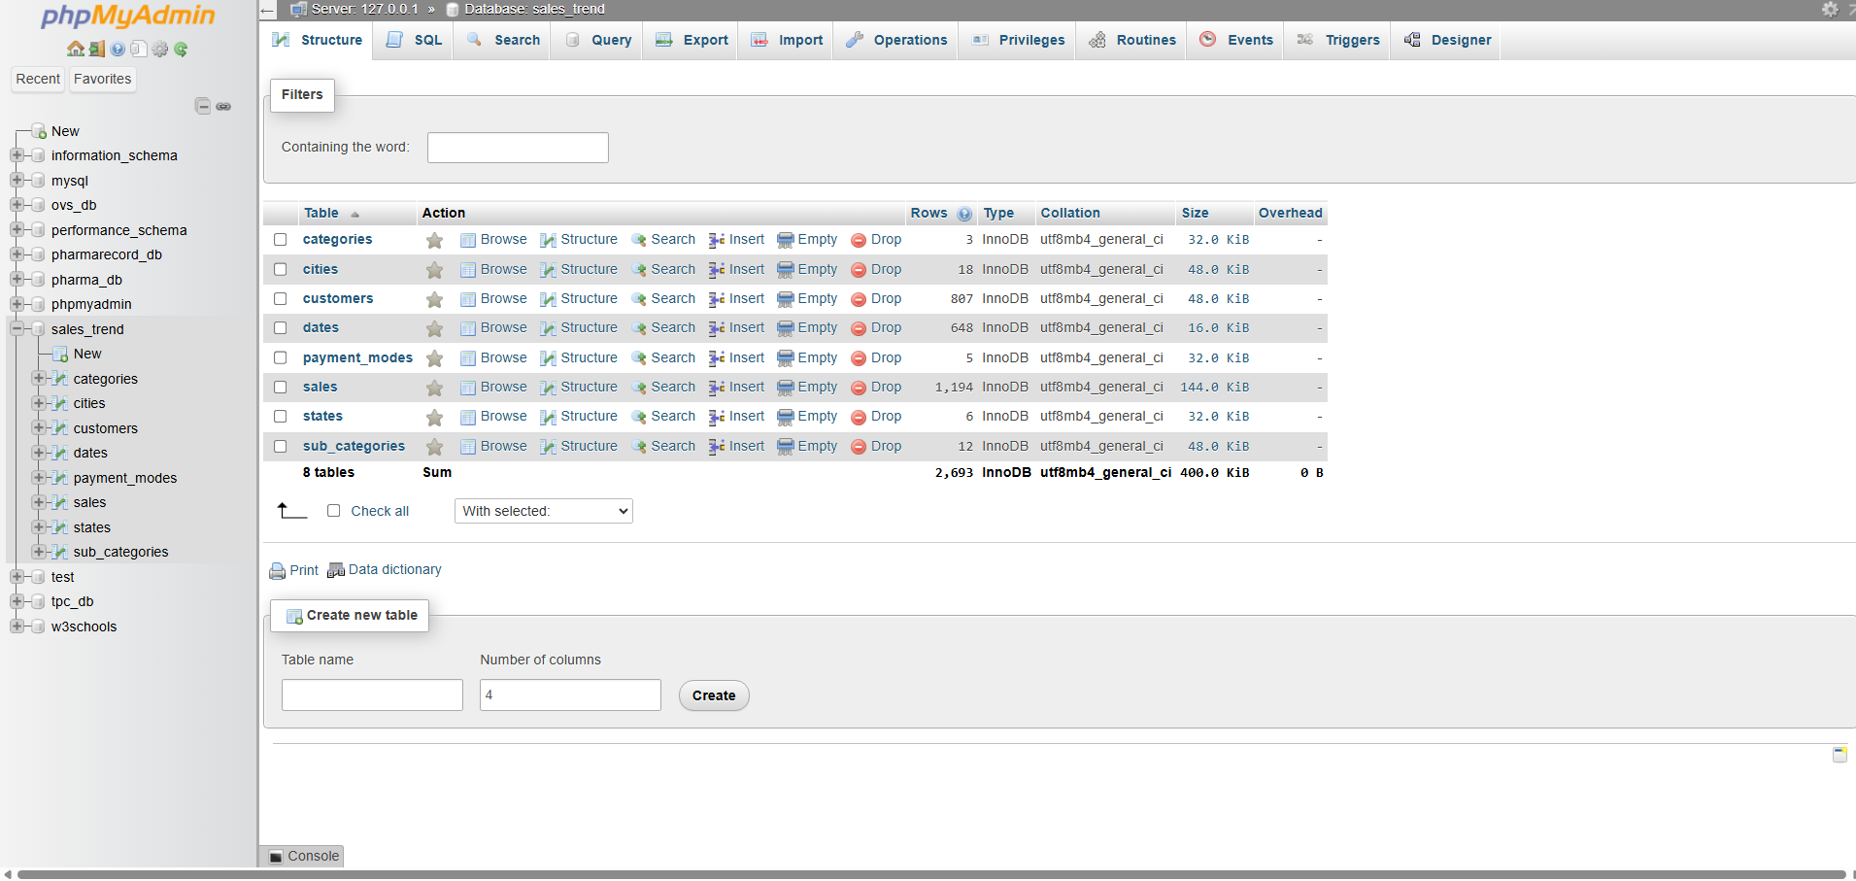
Screenshot 2 – Tables in the database structure
Screenshot 3 – Table Preview
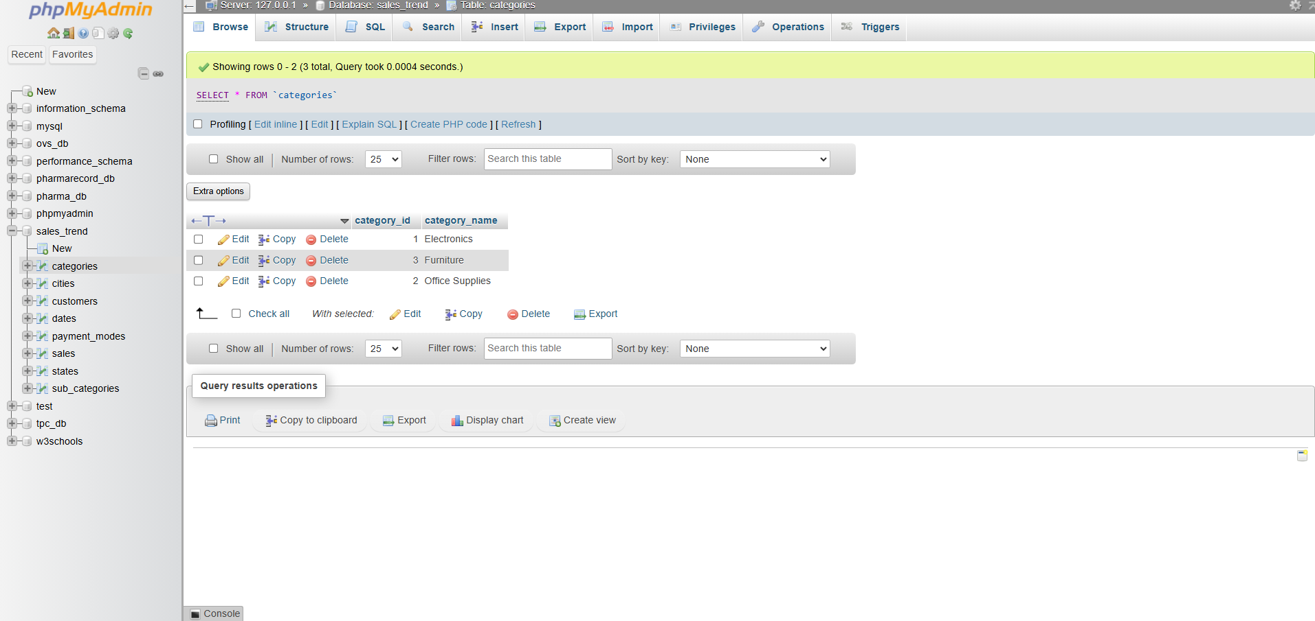
- Categories

- Cities Table
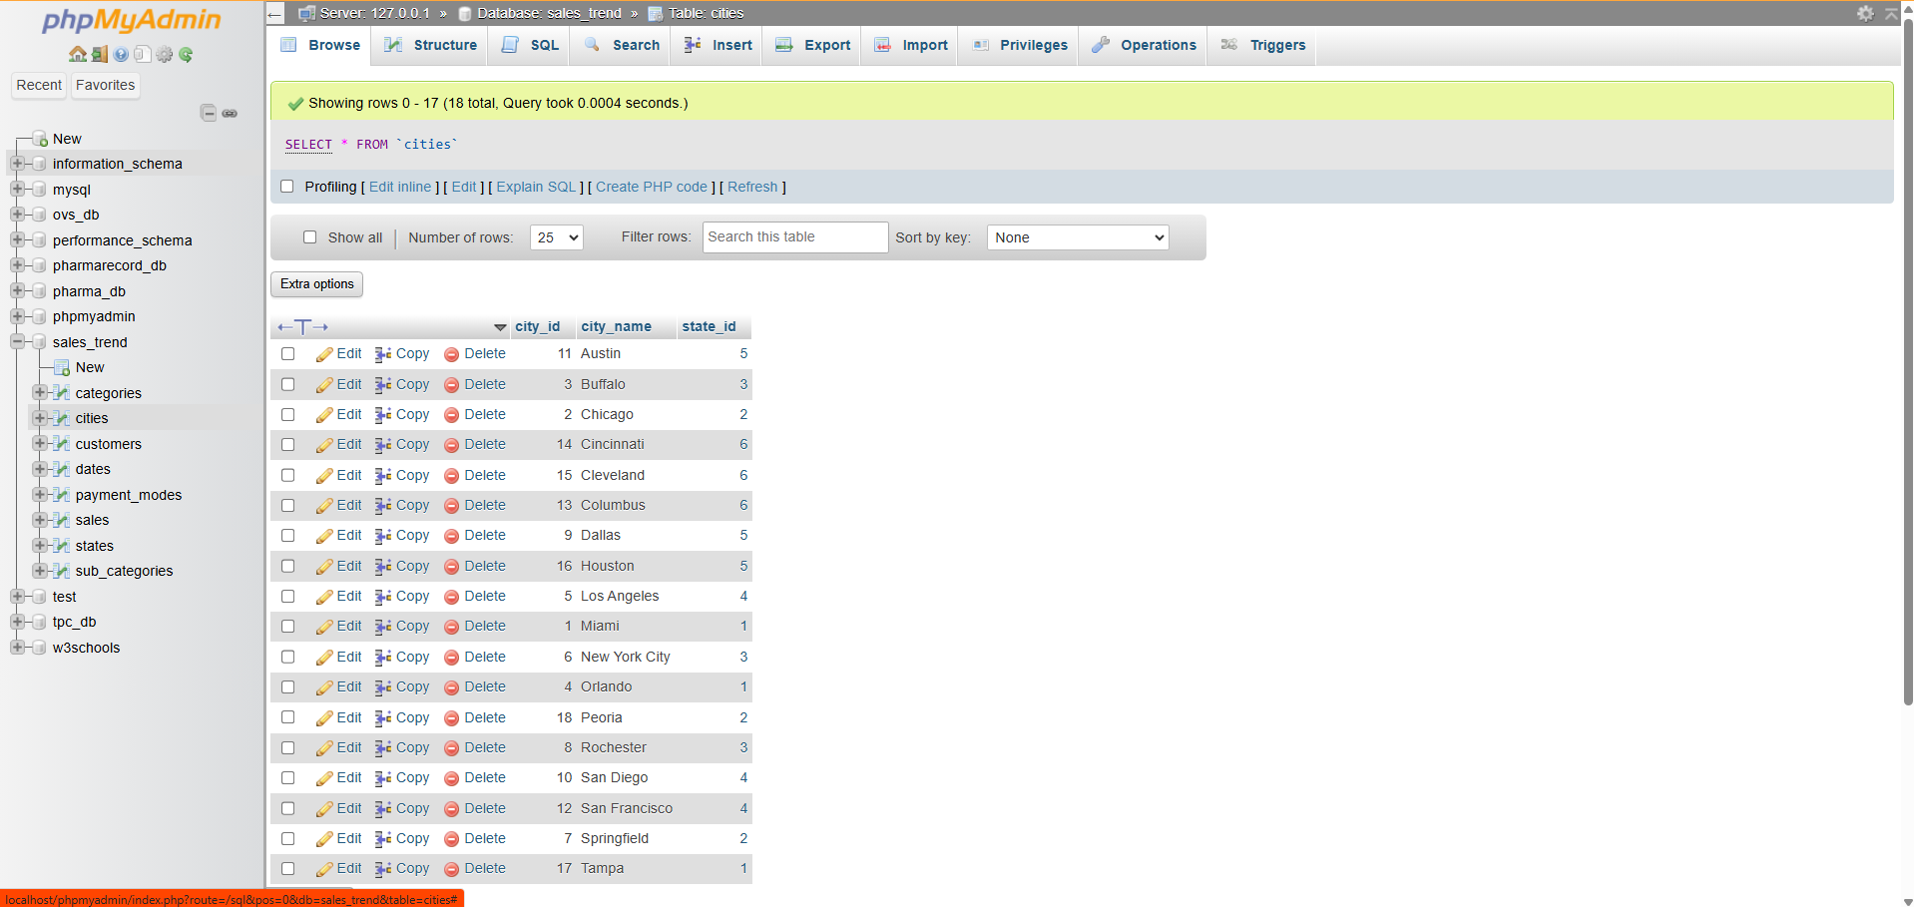
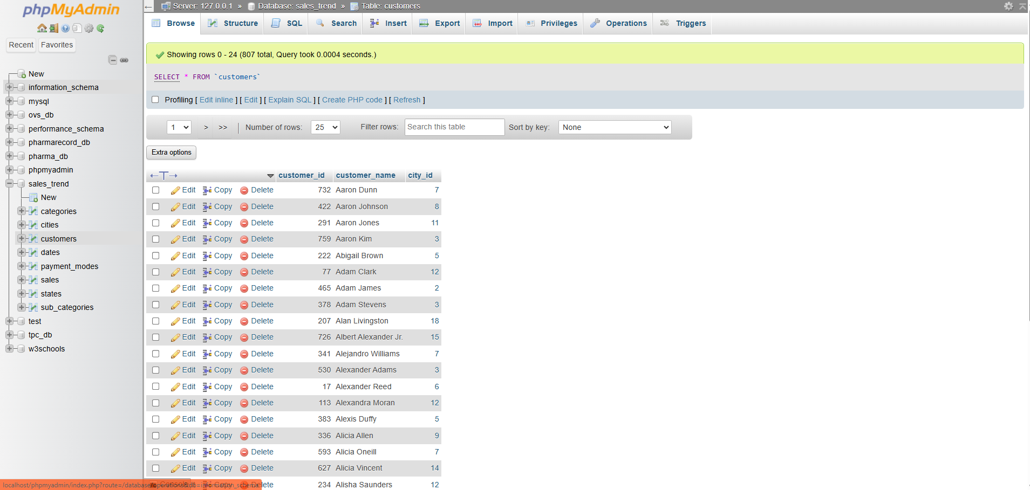
- Customers Table

- Dates Table
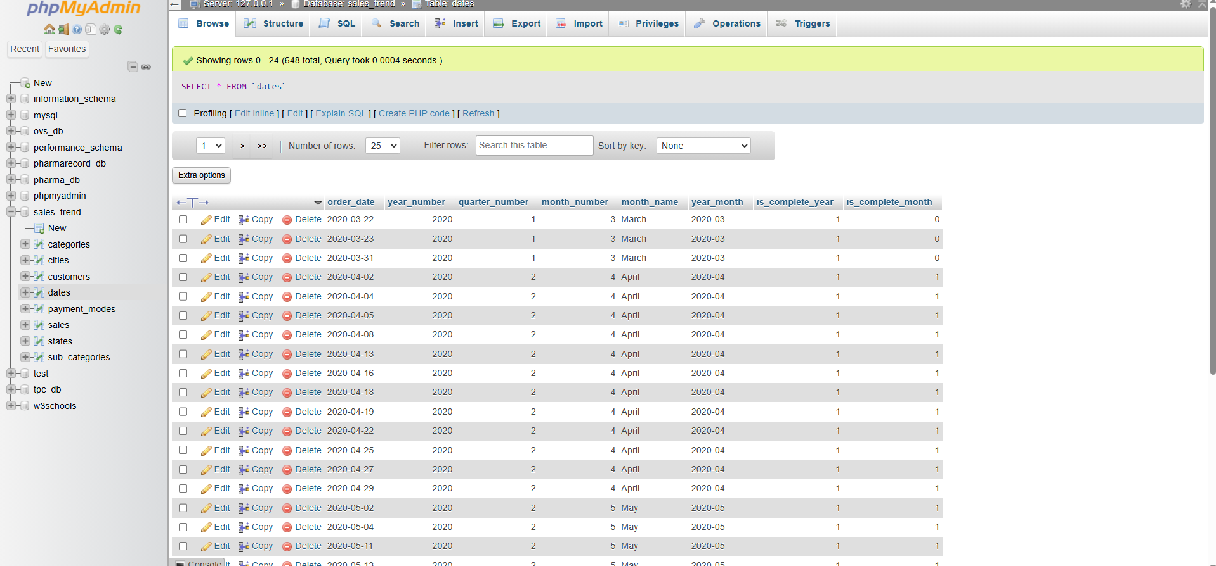

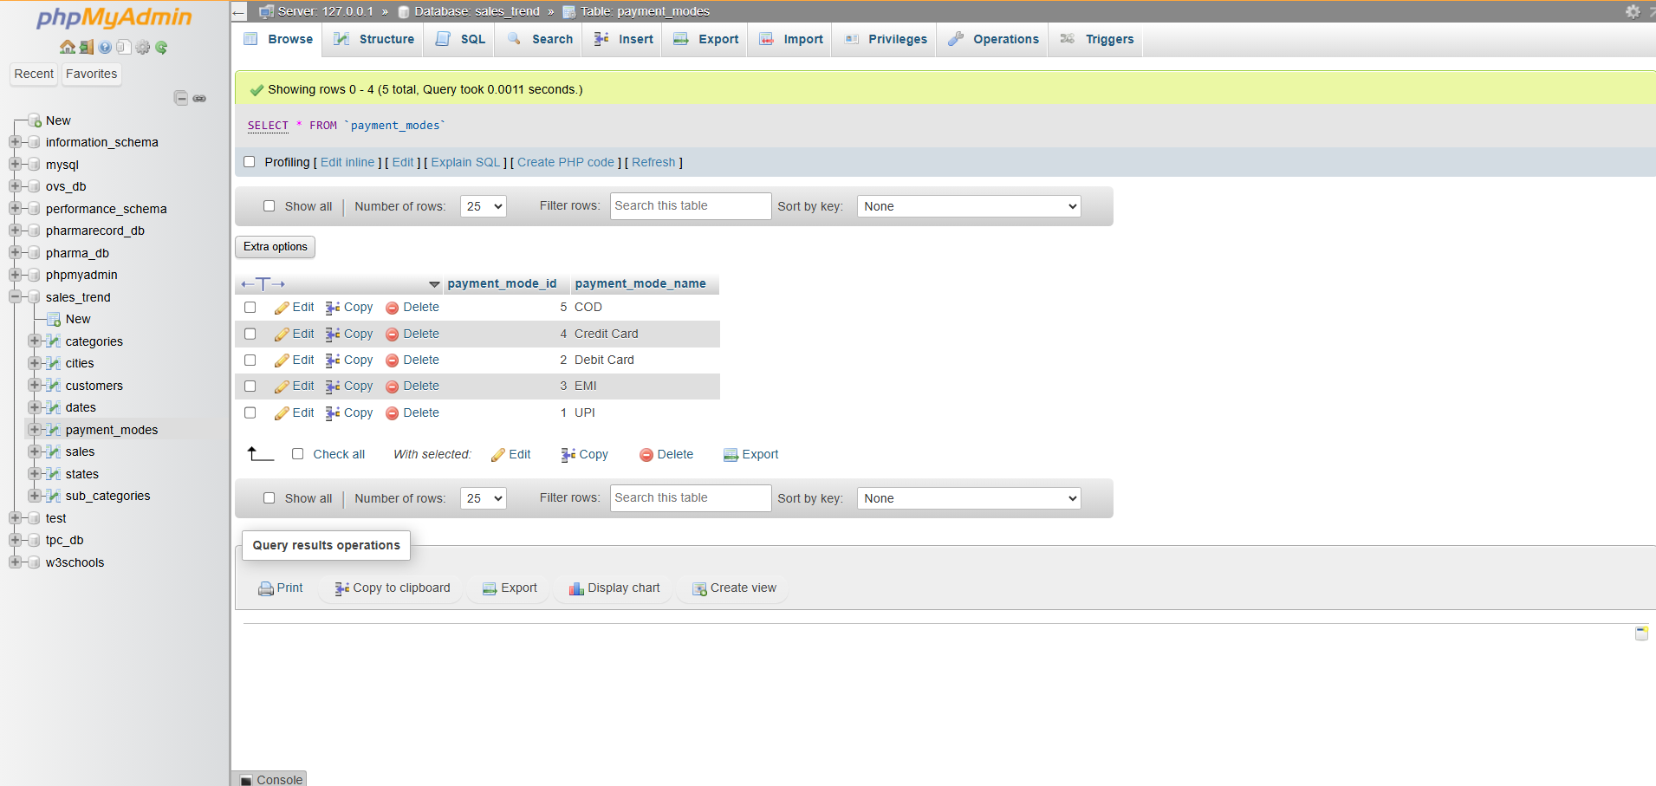
- Payment Mode Table
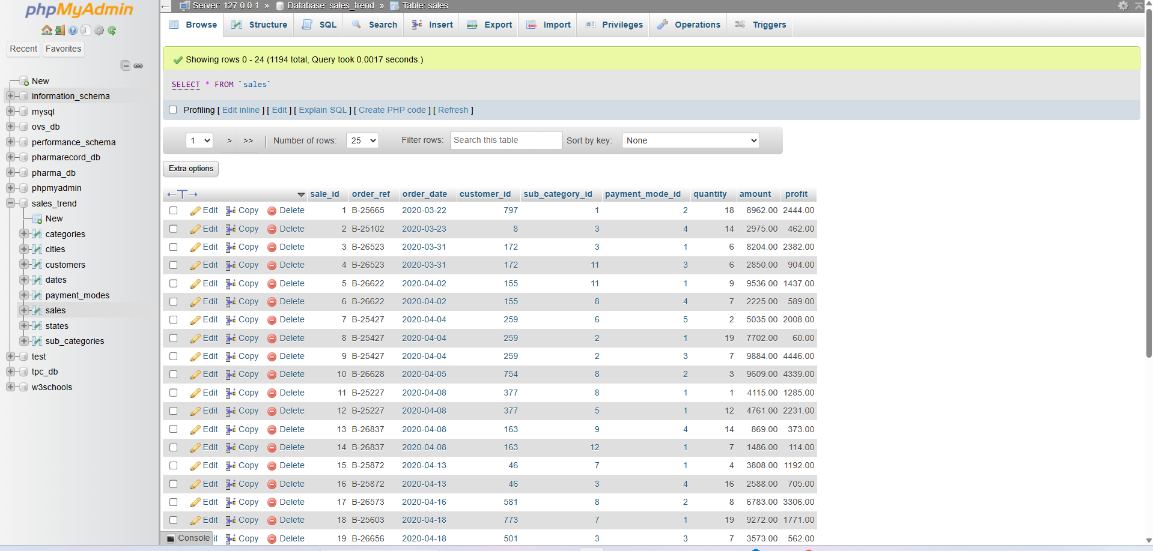
- Sales Table

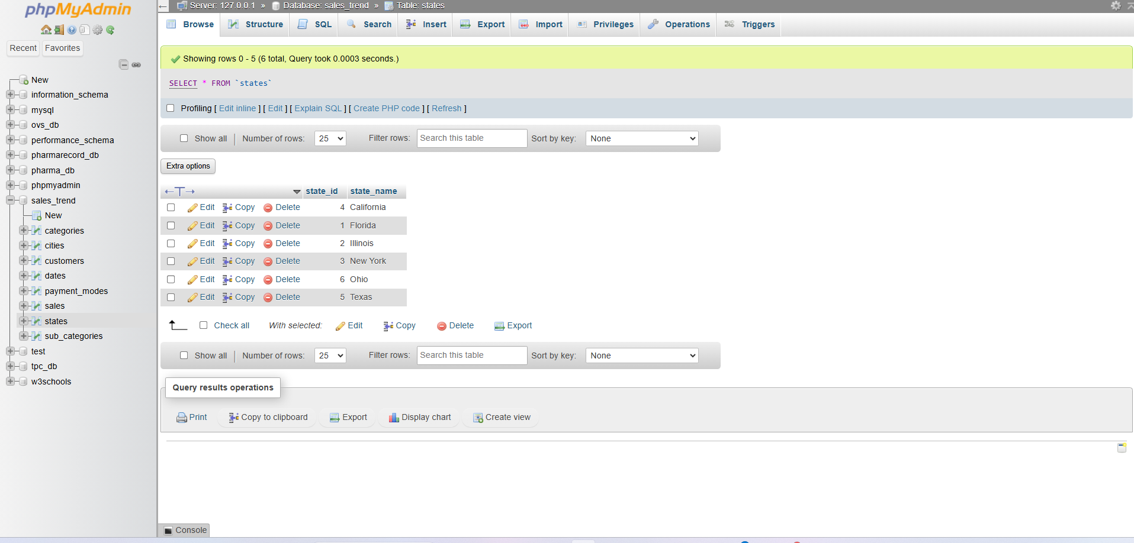
- States Table

- Sub Categories Table
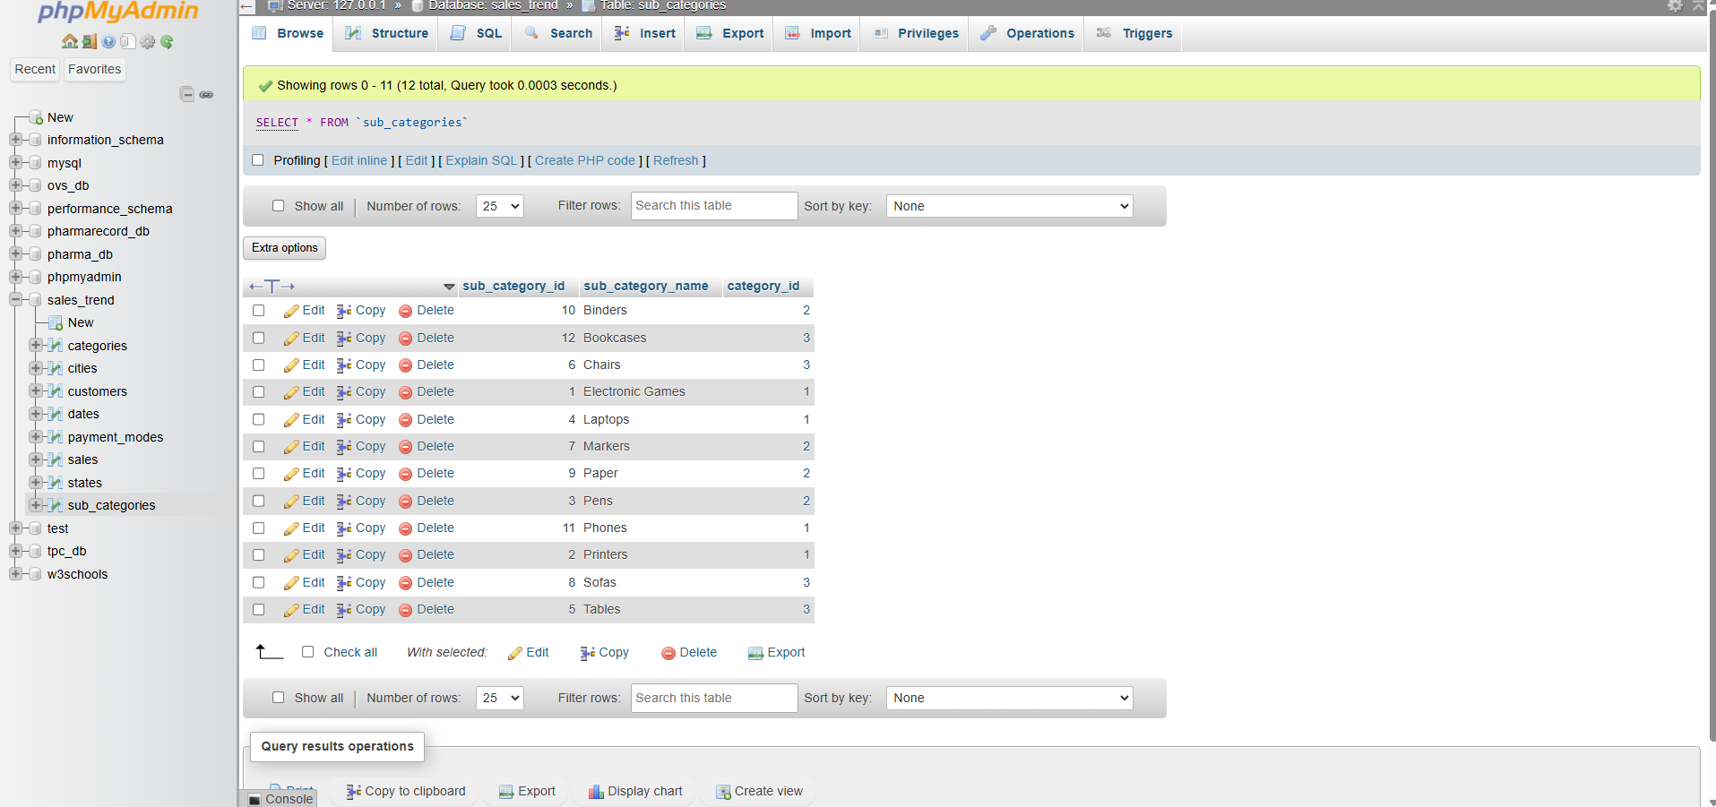

Task 1.4 — SQL Query Report

1. Basic Data Retrieval

Q1 — Largest transaction lines of the most recent complete year
SELECT / WHERE / ORDER BY on sales.
- SQL Code
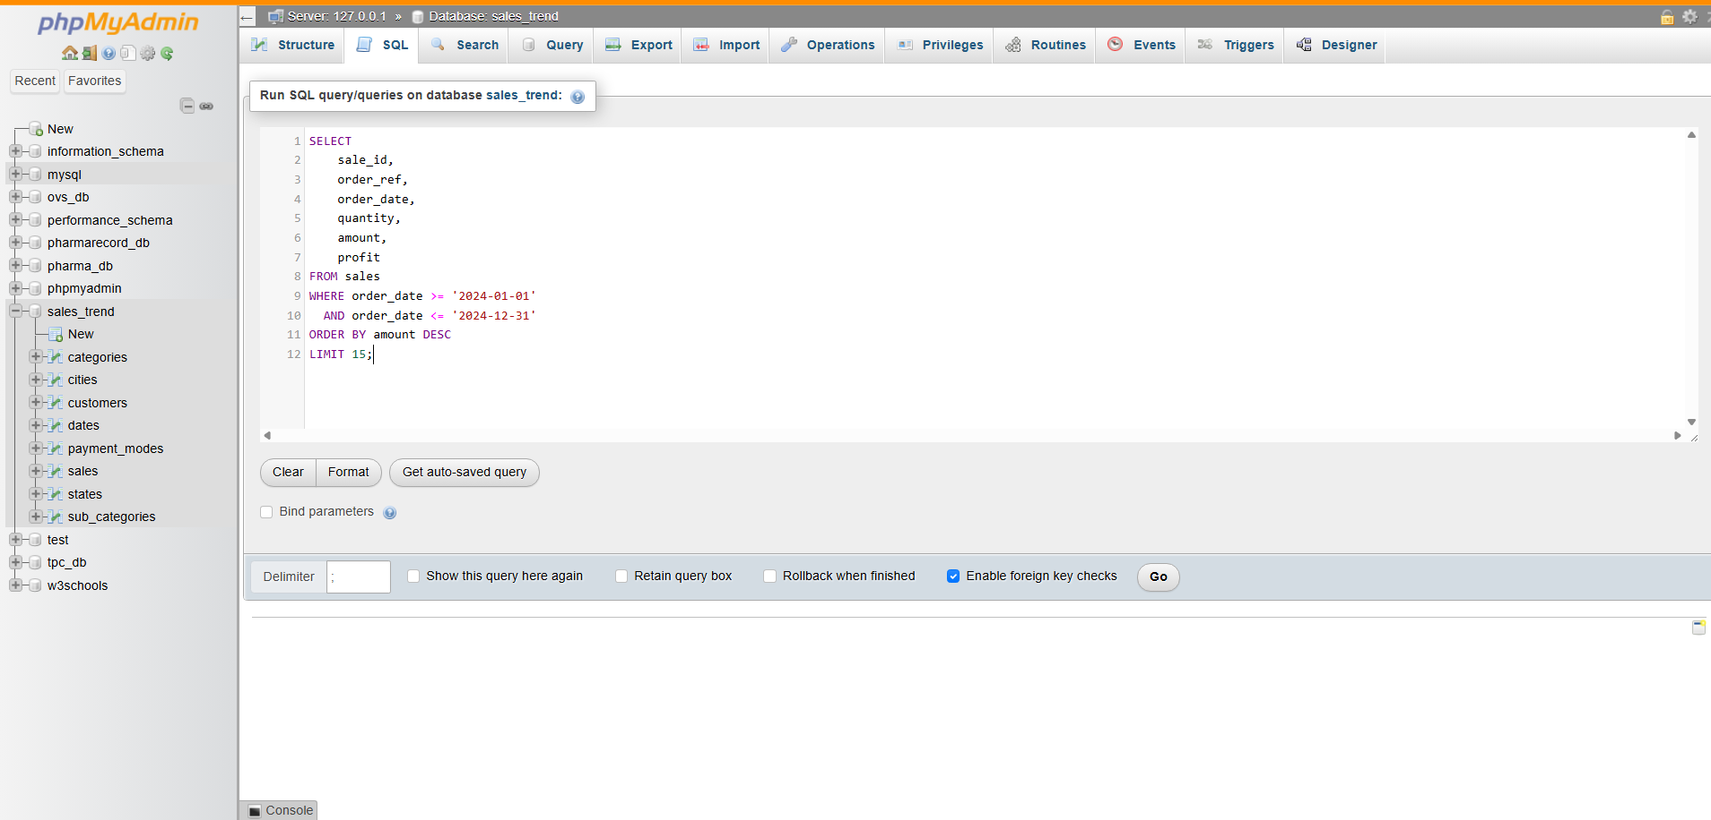
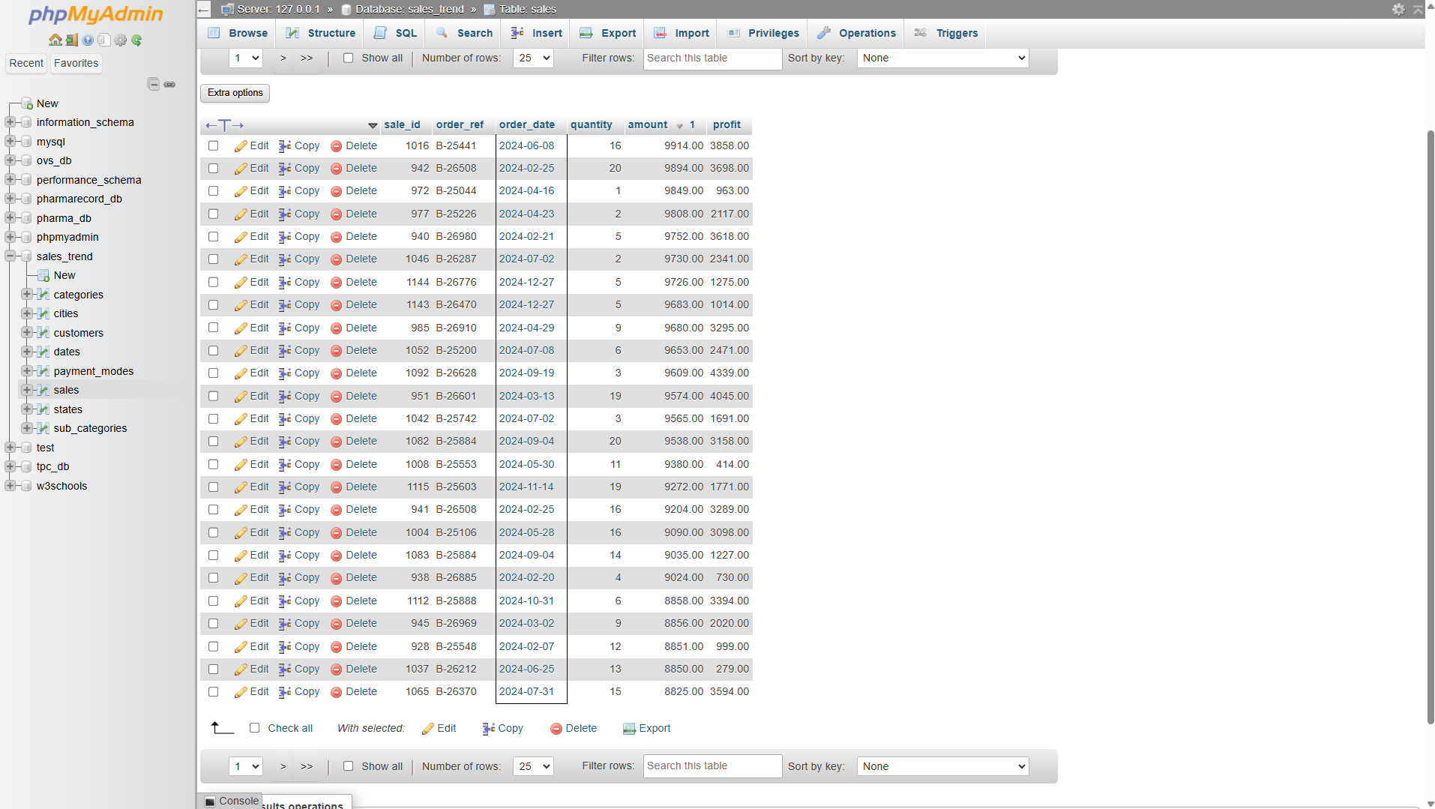
- Result
Business Interpretation. The 15 biggest lines of 2024 sit in a tight band from 9,380 to 9,914, against a dataset-wide maximum of 9,992 — so there is a hard ceiling near 10,000 rather than a long tail of outliers. This is a business of many mid-sized orders, not a few whales, which means no single lost account can explain the revenue decline.
Profit on those lines varies enormously, from 414 to 4,339 on near-identical revenue: sale 1008 returned 414 on 9,380 (4.4% margin) while sale 1092 returned 4,339 on 9,609 (45.2%). Order size alone is therefore a poor proxy for value, and any "top customer" report ranked on revenue would point management at exactly the wrong accounts.

Q2 — Bulk orders sold at thin margins
SELECT / WHERE / ORDER BY with a computed margin column.
- SQL Code
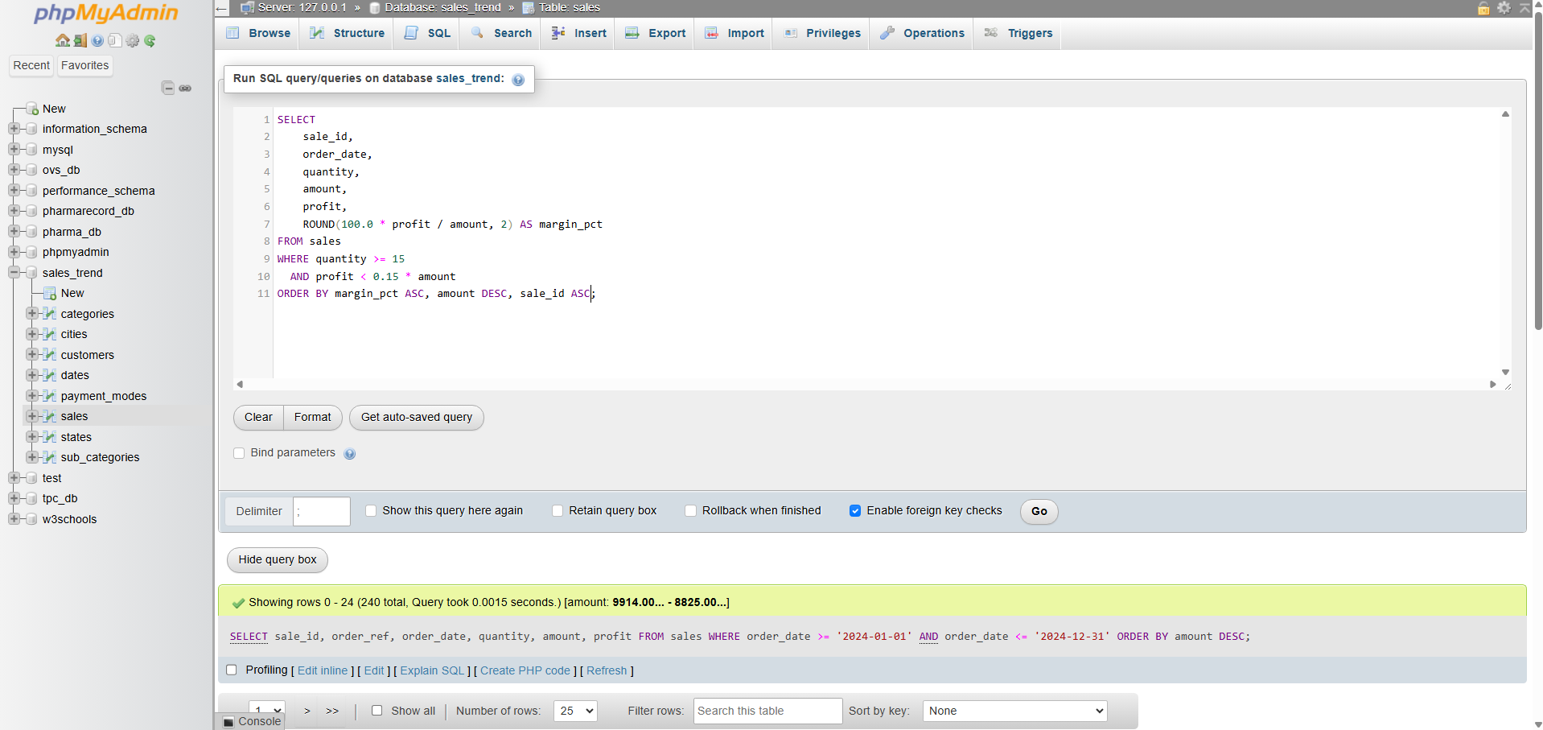
- Result
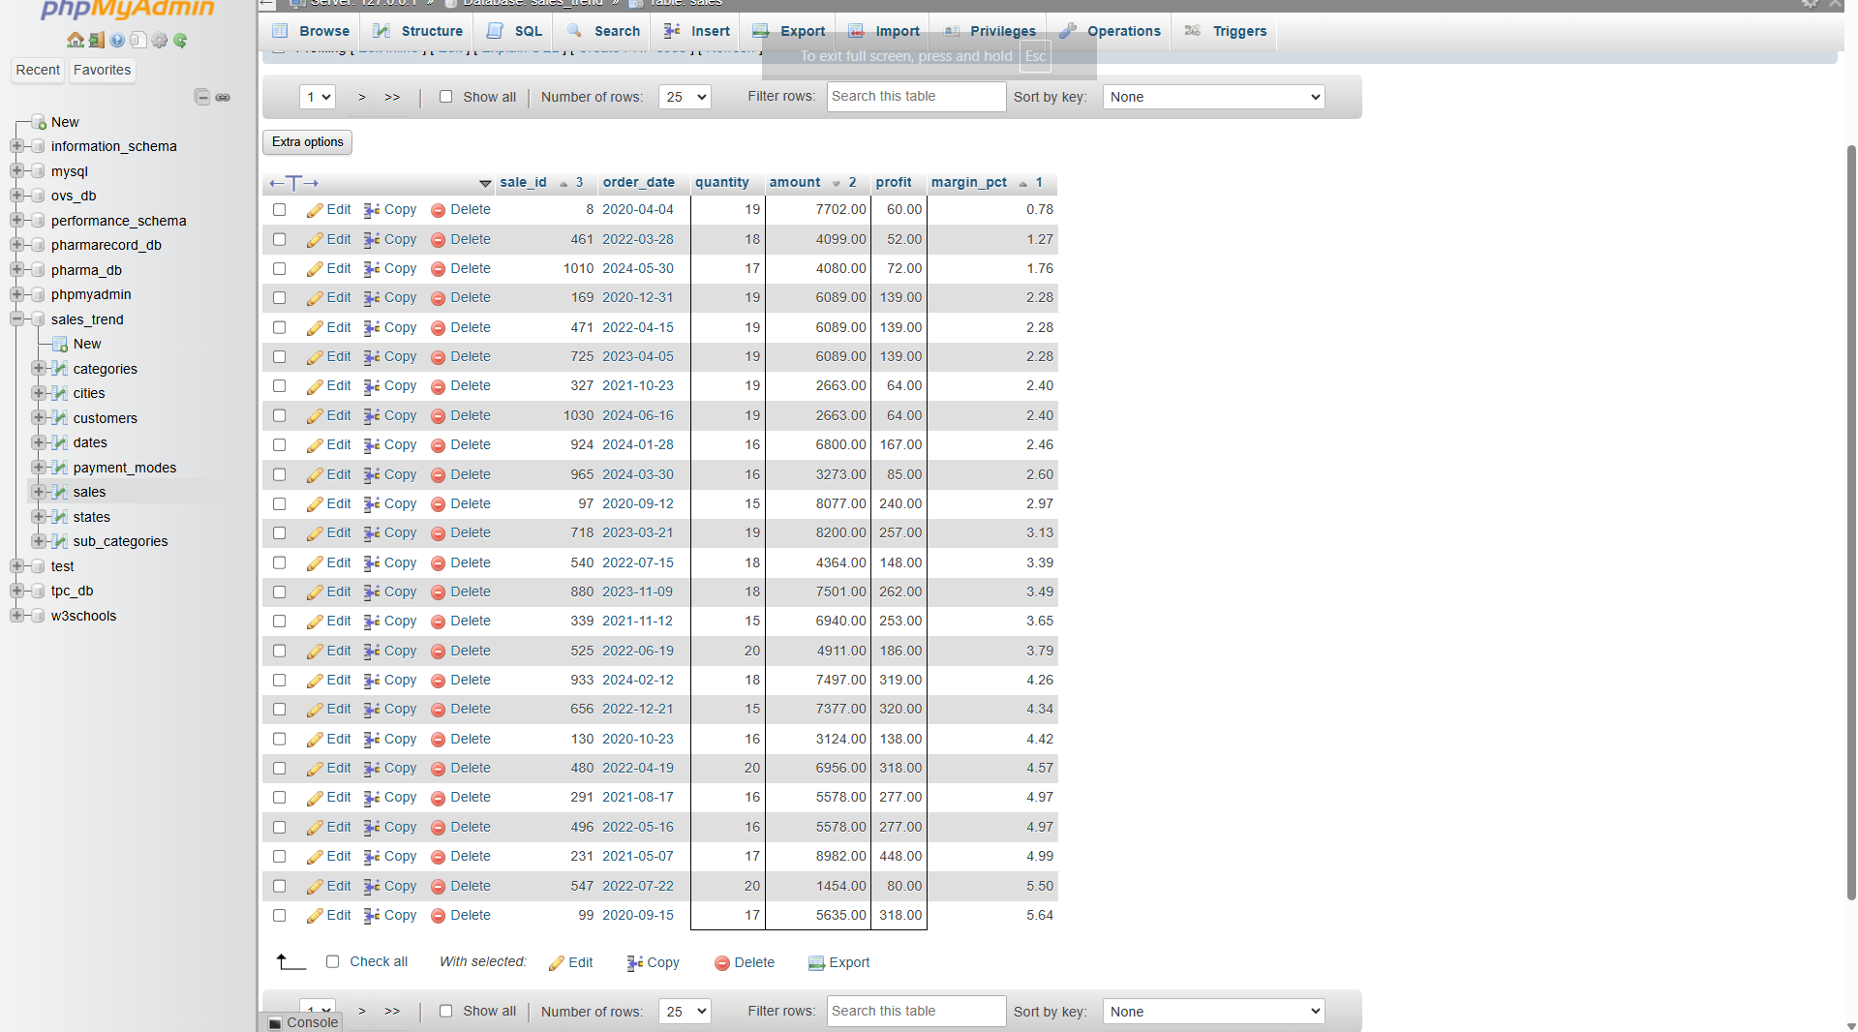
Business Interpretation. These are lines of 15+ units returning under 15% margin — the company moving maximum stock for minimum return. The worst, sale 8, shipped 19 units for 7,702 in revenue and just 60 in profit, a 0.78% margin; all 15 lines shown return under 3.7%. They are the first candidates for a price-floor or volume-discount review, since a recovery of even two percentage points on high-quantity lines compounds quickly across the order book.
Note that these thin-margin bulk lines appear in every year from 2020 to 2024, not only the declining years, so they are a standing pricing issue rather than a cause of the trend break identified in Q3.

2. Aggregate Analysis

Q3 — Annual sales trend, 2020–2024
GROUP BY with COUNT, SUM and AVG.
- SQL Code
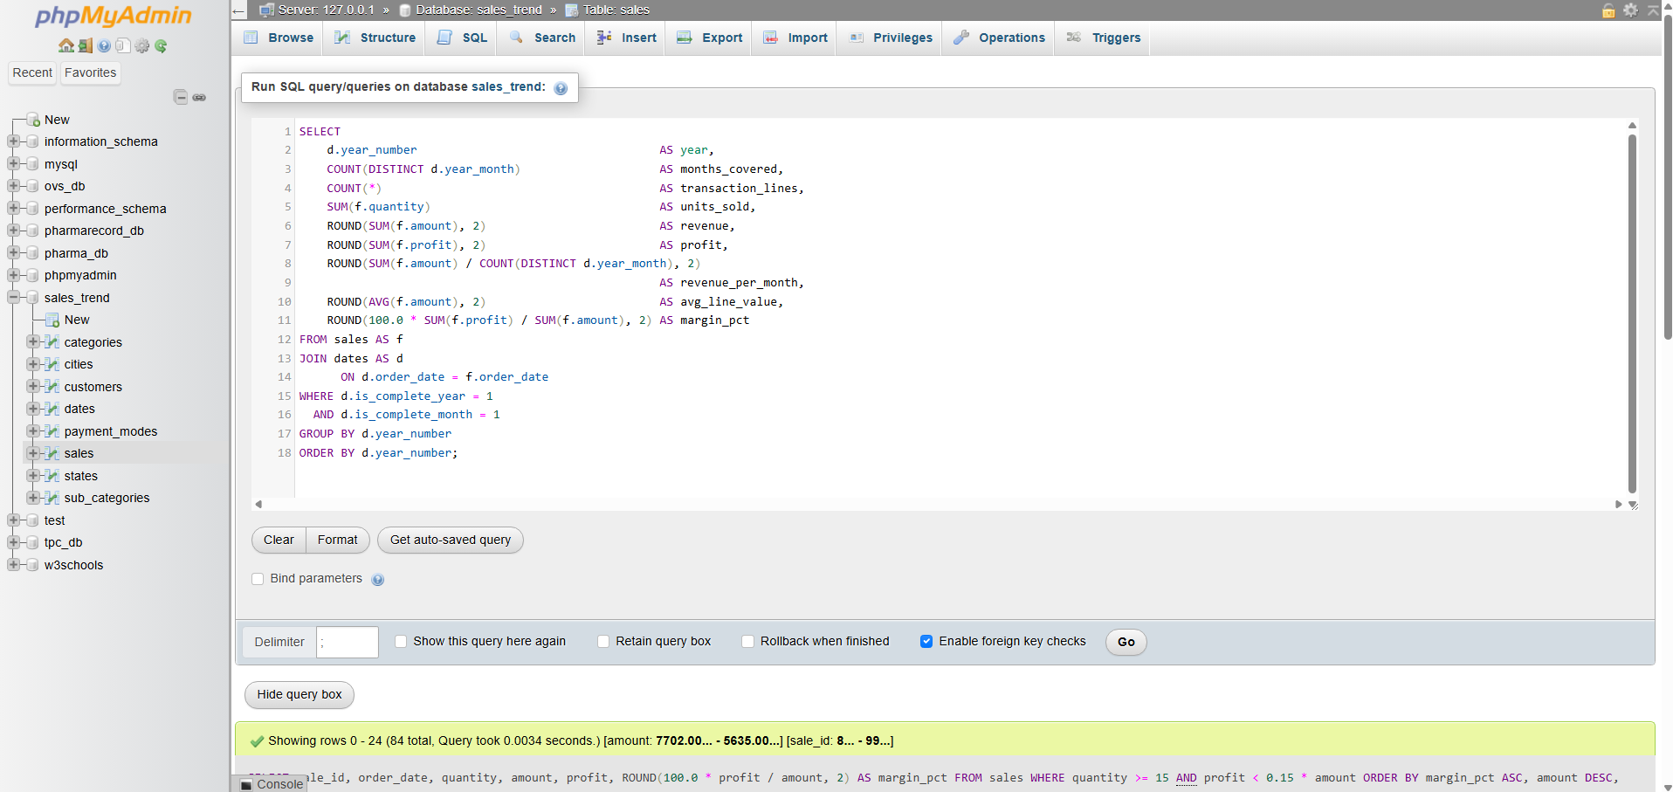
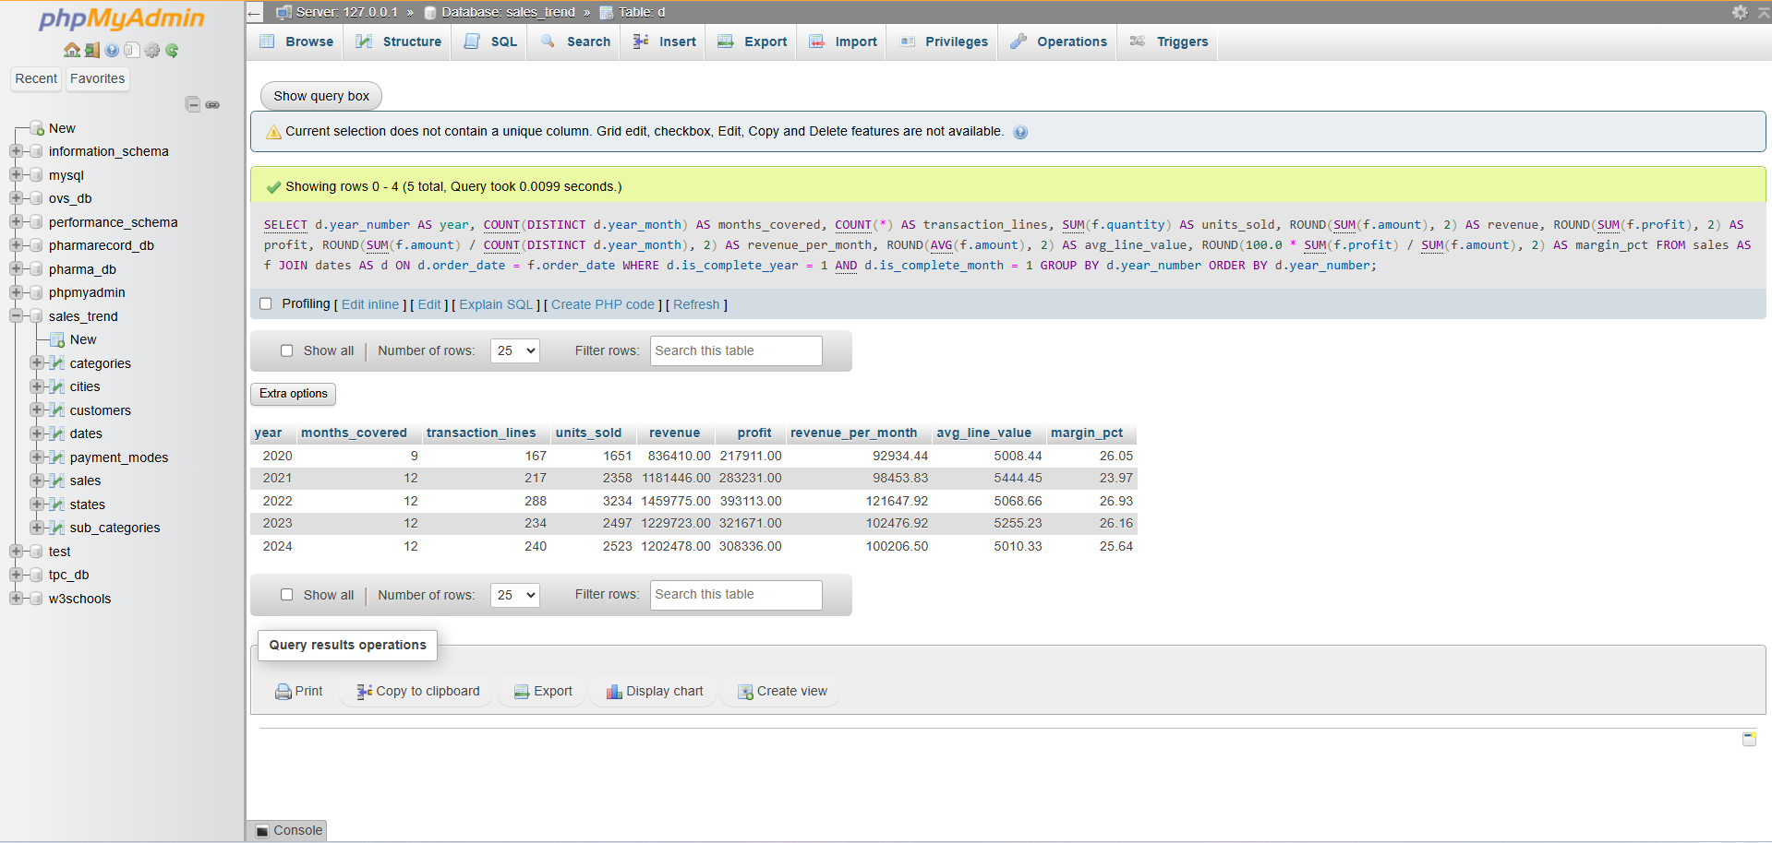
- Result

The 2024 average line value is exactly 5,010.325. MySQL rounds half away from zero and reports 5,010.33; tools that round half to even report 5,010.32._
Business Interpretation — answers Business Question 1. Growth stopped in 2022. Note the months column: 2020 holds only nine complete months, because the file begins on 22 March 2020, so the comparison must be made on revenue_per_month. On that basis revenue climbed 30.9% from 2020 to the 2022 peak, then fell 15.8% in 2023 and a further 2.2% in 2024, finishing 17.6% below the peak. The decisive detail is that average line value barely moved across all five years (5,008–5,444, a 9% spread) while transaction count moved a lot (18.6 lines per month in 2020, 24.0 in 2022, 20.0 in 2024). The company is not being forced into smaller or cheaper orders; it is simply writing fewer of them. That points the investigation at demand and product availability, not at pricing. Margin held between 23.97% and 26.93% throughout, confirming that profitability per sale was never the issue.
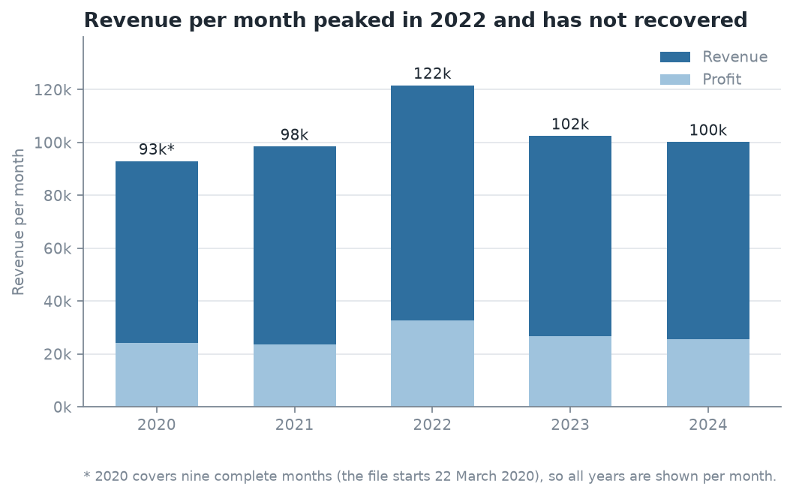
Figure 1. Annual revenue and profit, 2020–2024. Revenue peaked in 2022.

Q4 — Monthly seasonality, 2020–2024 pooled
GROUP BY month with a share-of-total subquery.
- SQL Code
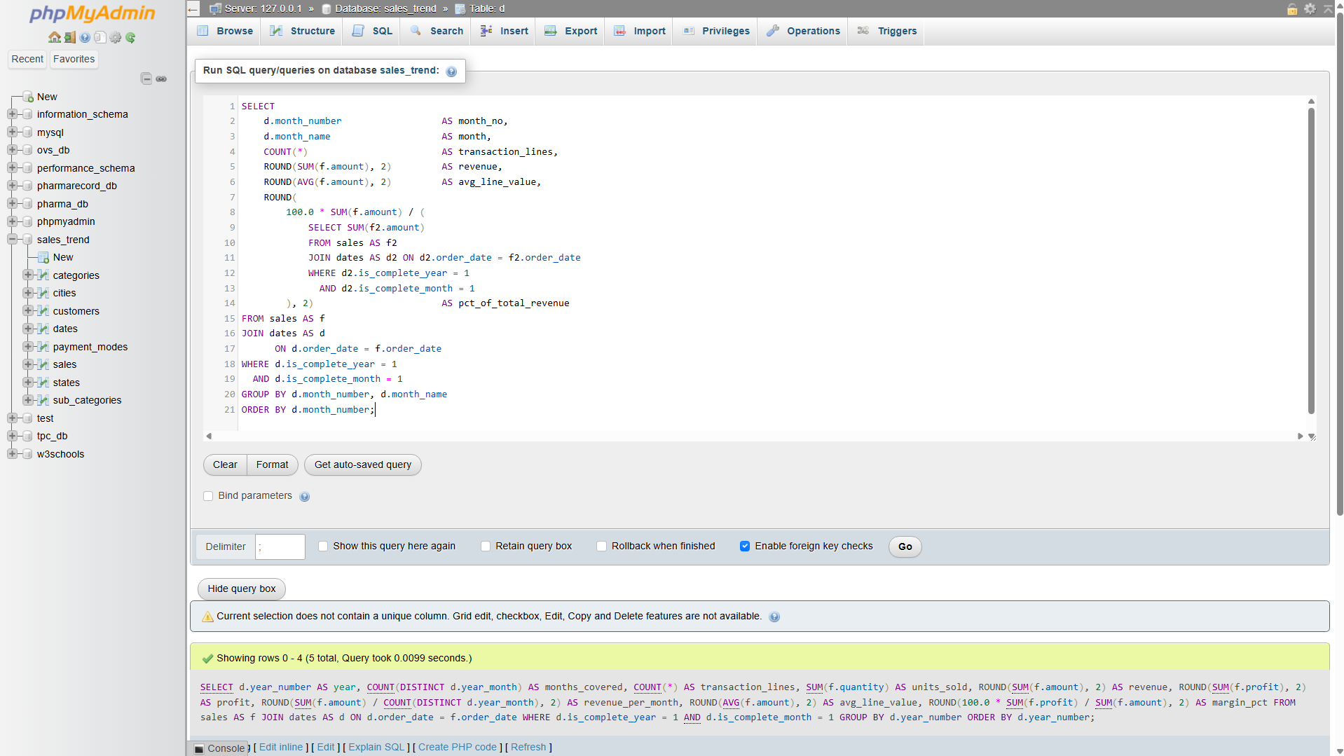

Result
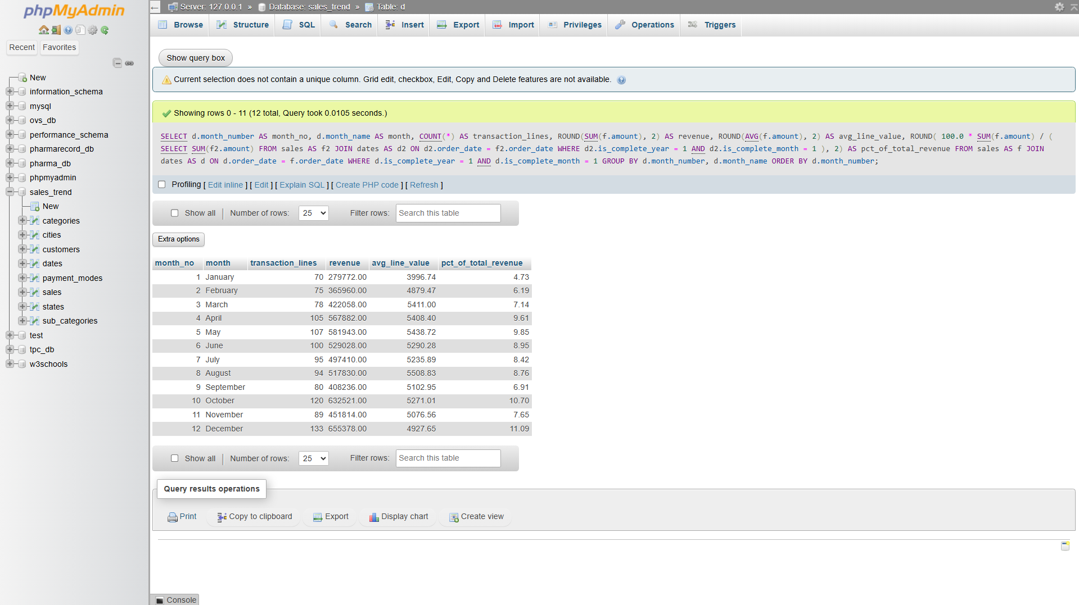
Business Interpretation — answers Business Question 3 (part 1). Demand is strongly seasonal and the peak is late. December (11.09% of annual revenue) and October (10.70%) are the two strongest months; Q4 as a whole carries 29.4% of the year against the 25% a flat distribution would give. January is the trough at 4.73% — barely 43% of a December. Notably the peak is driven by order count, not basket size: December records the most transaction lines of any month (133) on an average line value of 4,928 — below the 5,010–5,444 range of the annual averages in Q3. October is the same story, 120 lines at 5,271. The operational implication is that Q4 pressure is a throughput and fulfilment problem — more orders to pick, pack and ship — not a high-value-order problem, so the right response is staffing and warehouse capacity rather than premium stock.
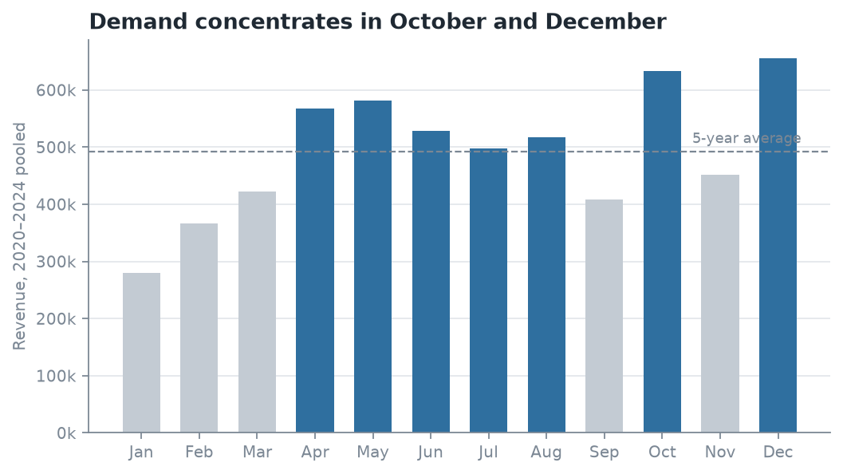
Figure 2. Revenue by calendar month, 2020–2024 pooled. Demand concentrates in October and December.

3. Multi-Table Joins

Q5 — Revenue by category per year
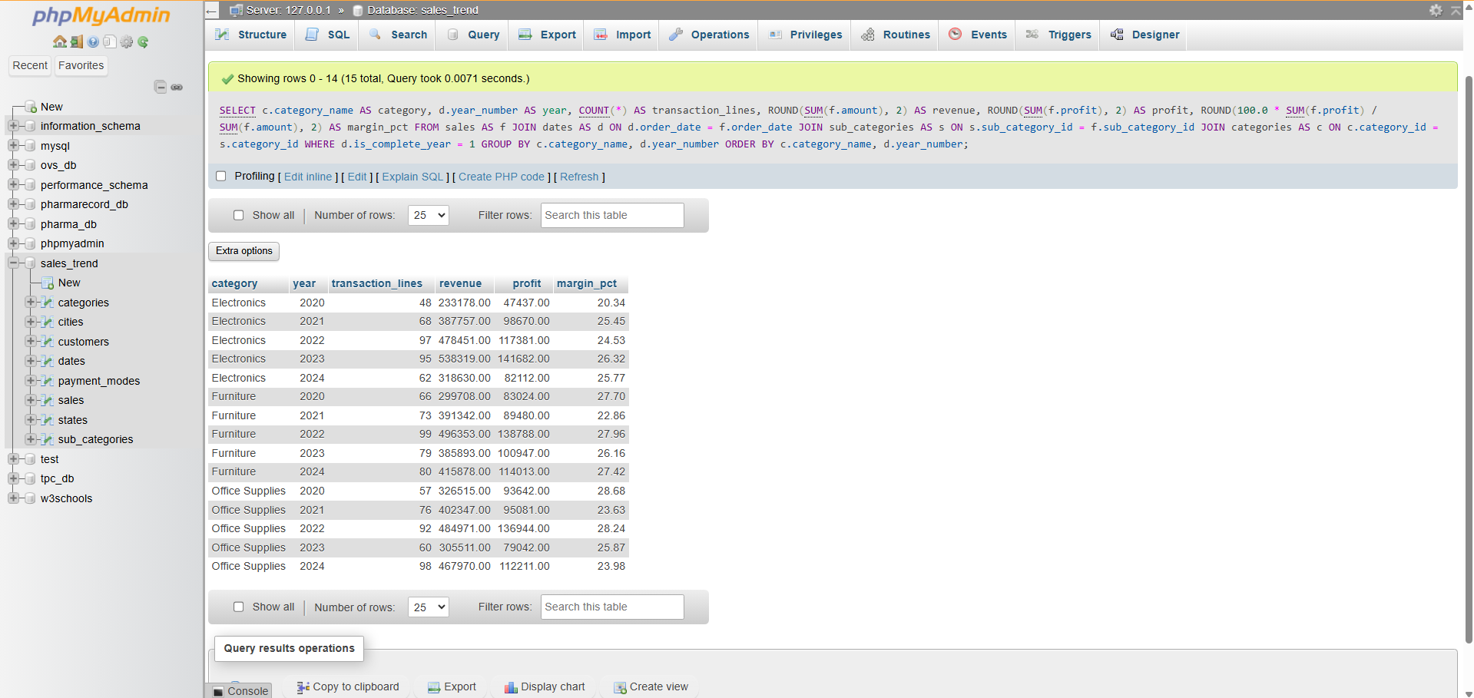
Joins 4 tables: sales → dates, sub_categories → categories.
- SQL Code

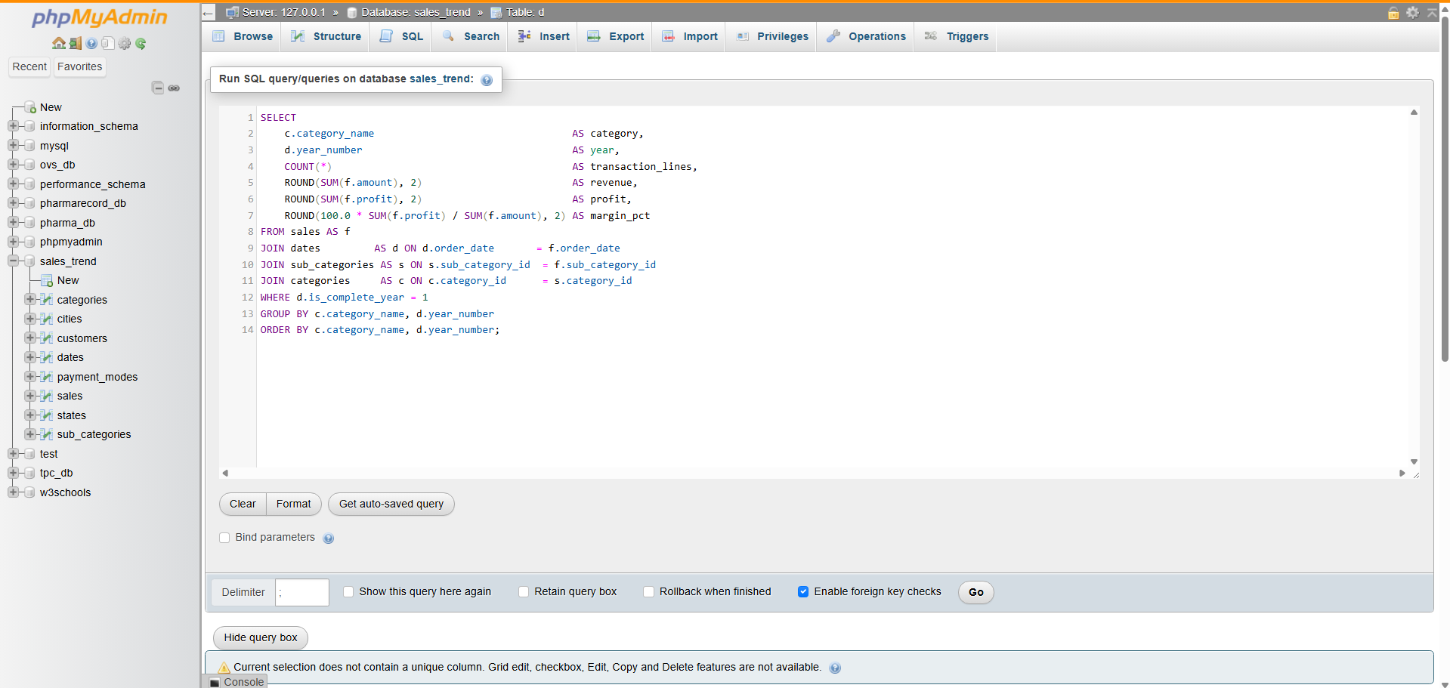
- Result

category | 2020 | 2021 | 2022 | 2023 | 2024
Electronics | 233,178 | 387,757 | 478,451 | 538,319 | 318,630
Furniture | 299,708 | 391,342 | 496,353 | 385,893 | 415,878
Office Supplies | 326,515 | 402,347 | 484,971 | 305,511 | 467,970
Table 8. Q5 — revenue by product category per year.
Business Interpretation — answers Business Question 2 (part 1). The flat company-level total hides three different stories. Electronics kept growing a year longer than the others, peaking in 2023 at 538,319, then fell 40.8% to 318,630 in 2024 — the single largest movement anywhere in the dataset. Office Supplies did the opposite: it dropped to 305,511 in 2023 and rebounded 53% to 467,970 in 2024. Furniture is the stable one, recovering modestly after 2023. So the 2024 "plateau" is really an Electronics collapse very nearly offset by an Office Supplies recovery. Managing to the aggregate number would have missed both.
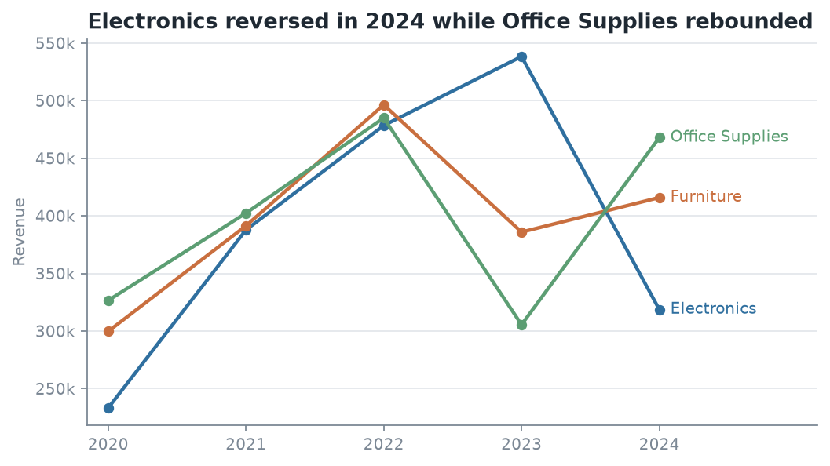
Figure 3. Revenue by product category per year. Electronics reversed in 2024 while Office Supplies rebounded.

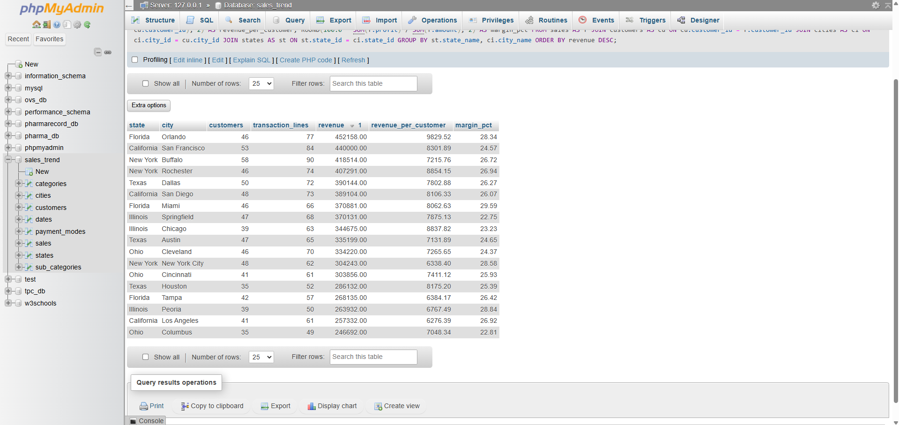
Q6 — Top cities by revenue and revenue per customer
Joins 4 tables: sales → customers → cities → states.
- SQL Code
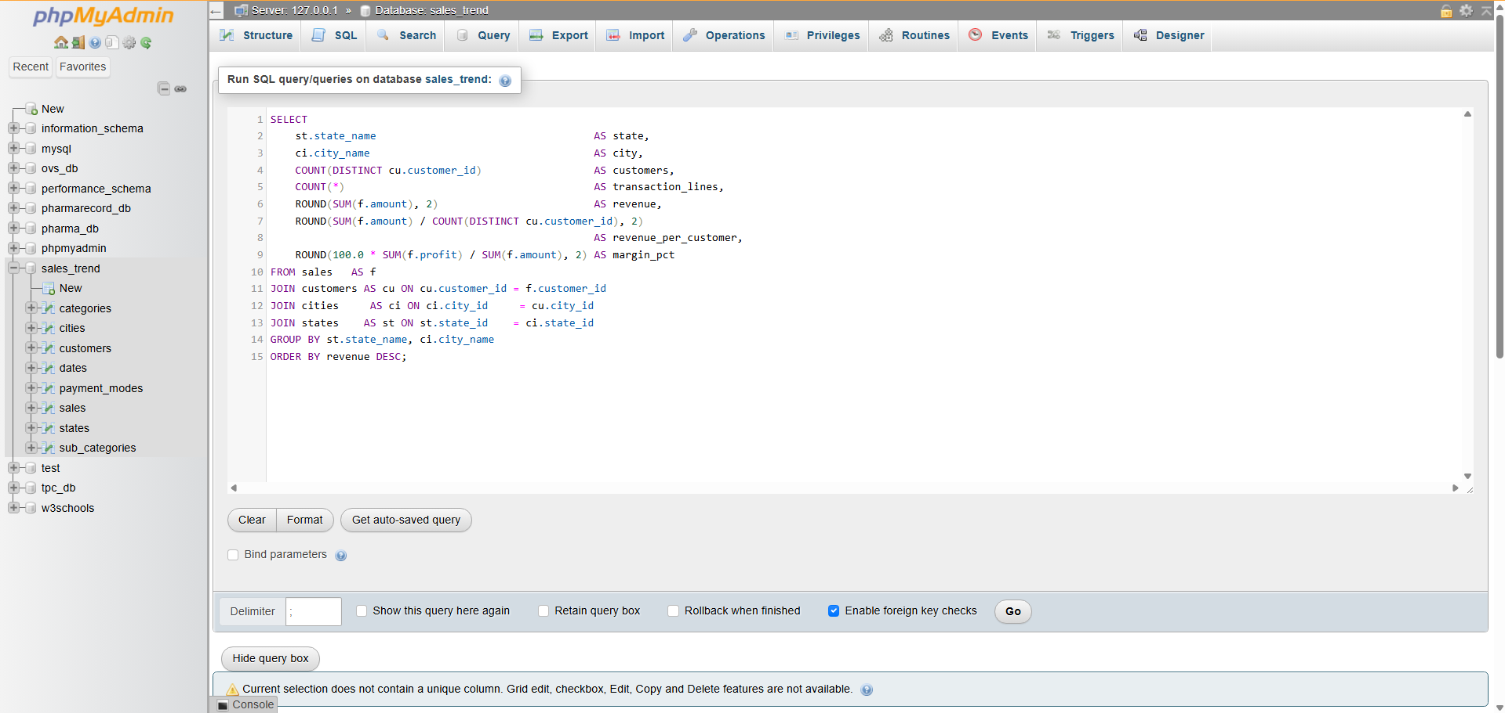
- Result

state | city | customers | revenue | revenue_per_customer | margin_pct
Florida | Orlando | 46 | 452,158 | 9,829.52 | 28.34
California | San Francisco | 53 | 440,000 | 8,301.89 | 24.57
New York | Buffalo | 58 | 418,514 | 7,215.76 | 26.72
New York | Rochester | 46 | 407,291 | 8,854.15 | 26.94
Texas | Dallas | 50 | 390,144 | 7,802.88 | 26.27
Table 9. Q6 — top cities by revenue and revenue per customer.
Business Interpretation. Geography is not where the problem lies. Total revenue across the six states spans only 884,768 (Ohio) to 1,130,048 (New York) — a 28% spread over five years, which is remarkably even. The more useful signal is per-customer value: Orlando returns 9,829 per customer at a 28.34% margin, while Buffalo generates comparable total revenue from 26% more customers at 7,216 each. Buffalo's revenue is bought with more customer relationships to service, so acquisition spend is better aimed at Orlando-like markets. This confirms the trend problem is national and product-driven, not regional — which is what makes Q7 the decisive query.

4. Business-Relevant Insights

Q7 — Which sub-categories turned growth into a plateau? (Business Question 2)
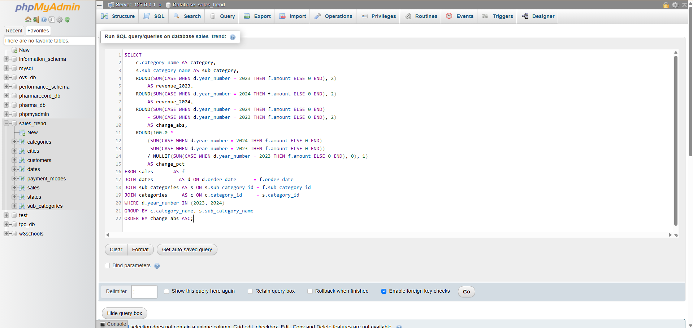
Conditional aggregation comparing 2023 with 2024 across all 12 sub-categories.
- SQL Code

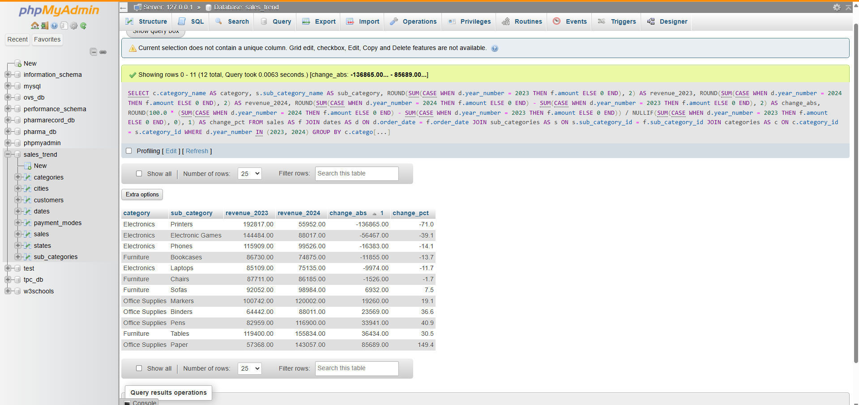
- Result
category | sub_category | revenue_2023 | revenue_2024 | change_abs | change_pct
Electronics | Printers | 192,817 | 55,952 | −136,865 | −71.0
Electronics | Electronic Games | 144,484 | 88,017 | −56,467 | −39.1
Electronics | Phones | 115,909 | 99,526 | −16,383 | −14.1
Furniture | Bookcases | 86,730 | 74,875 | −11,855 | −13.7
Electronics | Laptops | 85,109 | 75,135 | −9,974 | −11.7
Furniture | Chairs | 87,711 | 86,185 | −1,526 | −1.7
Furniture | Sofas | 92,052 | 98,984 | +6,932 | +7.5
Office Supplies | Markers | 100,742 | 120,002 | +19,260 | +19.1
Office Supplies | Binders | 64,442 | 88,011 | +23,569 | +36.6
Office Supplies | Pens | 82,959 | 116,900 | +33,941 | +40.9
Furniture | Tables | 119,400 | 155,834 | +36,434 | +30.5
Office Supplies | Paper | 57,368 | 143,057 | +85,689 | +149.4
Table 10. Q7 — sub-category revenue change, 2023 vs 2024.
Business Interpretation — the headline finding. The plateau is not broad weakness; it is concentrated in one sub-category. Printers alone lost 136,865 — more than half the entire 257,297 gap between the 2022 peak and 2024, and more than the next two decliners combined. Every one of the top four decliners is an Electronics line, and all four Electronics sub-categories fell. Meanwhile all four Office Supplies lines grew, led by Paper at +149.4%.
The pattern is coherent enough to name a hypothesis: consumables (Paper, Pens, Binders, Markers) are growing while durable electronics hardware is falling away. That is the signature of either a supply problem on the hardware side — stockouts, a lost supplier, a discontinued line — or a deliberate customer shift toward repeat consumable purchasing. The immediate action is to check 2024 Printer stock availability and supplier status before any demand-side conclusion is drawn, because a supply failure and a demand collapse look identical in a sales table and require opposite responses.

Q8 — Is the Q4 peak company-wide or category-specific? (Business Question 3)
Quarterly revenue per category with a window function giving each quarter's share of that category's own total.
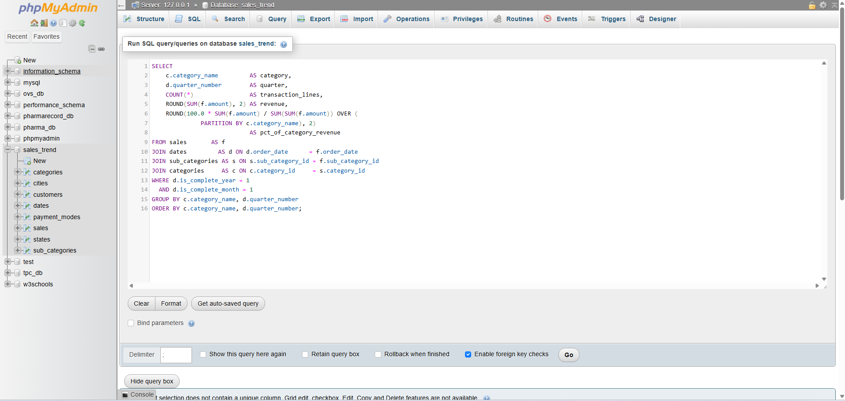
- SQL Code

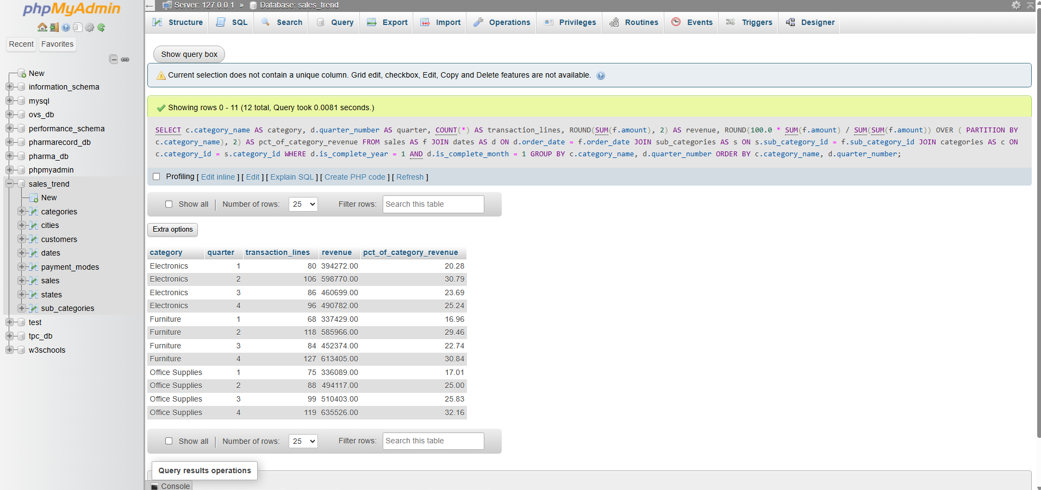
- Result
category | Q1 | Q2 | Q3 | Q4
Electronics | 20.28% | 30.79% | 23.69% | 25.24%
Furniture | 16.96% | 29.46% | 22.74% | 30.84%
Office Supplies | 17.01% | 25.00% | 25.83% | 32.16%
Table 11. Q8 — each quarter's share of its own category's annual revenue.
Business Interpretation. The company-wide Q4 peak is not universal, and this is the finding most likely to change how the business plans. Furniture and Office Supplies both peak in Q4 (30.8% and 32.2% of their own annual revenue), consistent with holiday and new-fiscal-year buying. Electronics does not — it peaks in Q2 at 30.79% and Q4 is only its second-best quarter. Planning Electronics inventory against the blended company seasonal curve therefore over-stocks it in Q4 and under-stocks it in Q2, every year.
The recommendation is to replace the single company seasonal curve with per-category curves: Q4-weighted for Furniture and Office Supplies, Q2-weighted for Electronics. Q1 is the weakest quarter for all three (17–21%), so it is the natural window for clearance and maintenance.

Summary of Findings
- Growth stopped in 2022. Revenue per month is 17.6% below its peak, but margin never moved and average order value never moved — the company is writing fewer orders, not worse ones. (Q3)
- One sub-category explains most of it. Printers lost 136,865 between 2023 and 2024, over half the entire peak-to-2024 gap. All Electronics fell; all Office Supplies grew. (Q5, Q7)
- Seasonality is category-specific. Electronics peaks in Q2, Furniture and Office Supplies in Q4. The blended curve currently used for planning is wrong for all three. (Q4, Q8)
- Geography is not a factor. State revenue spans only 28% over five years; the problem is national and product-driven. (Q6)
Recommended next step for Checkpoint 2: verify the Printer supply hypothesis against stock and supplier records, then model monthly revenue with per-category seasonal terms rather than a single company-wide index.
Stated limitation. As noted in Task 1.2, the source file contains no loss-making transactions and an implausibly even payment-method split, so it is likely synthetic. The analysis method, schema and queries are valid; the specific figures should be presented as a modelling exercise rather than as a real company's trading results.

Reproducibility
Artefact | Path
Raw data | data/raw/sales_dataset_raw.csv / https://www.kaggle.com/datasets/shantanugarg274/sales-dataset?
Cleaned tables | data/processed/*.csv
MySQL schema | sql/01_schema_mysql.sql
Generated INSERTs | sql/03_insert_data.sql
Query set | sql/04_queries.sql
Full query output | reports/query_results.md
Data quality evidence | reports/data_quality_report.md
ERD | docs/erd.md
Table 12. Project artefacts and their locations in the repository.

